1 Title:

2 Health and disease imprinted in the time variability

3 of the human microbiome

4 Running title:

5

Microbiota, are you sick?

6 **Jose Manuel Martí**1,2,*∗***, Daniel Martínez-Martínez**1,2,3,*∗***, Manuel Peña**2**, César Gracia**1,2**,**

7 **Amparo Latorre**1,3,4,5**, Andrés Moya**1,3,4,5,# **& Carlos P. Garay**1,2,#

8 1Institute for Integrative Systems Biology (I2SysBio), 46980, Spain.

9 2Instituto de Fisica Corpuscular, CSIC-UVEG, P.O. 22085, 46071, Valencia, Spain.

10 3FISABIO, Avda de Catalunya, 21, 46020, Valencia, Spain.

11 4Cavanilles Institute of Biodiversity and Evolutionary Biology, UVEG, 46980, Spain.

12 5CIBER en Epidemiología y Salud Pública (CIBEResp), Madrid, Spain

13 Words count for the Abstract section: 154 of 250 max

14 Words count for the Importance section: 105 of 150 max

15 Words count for the rest of text (inc.refs.): 5454

16

*∗* Equally contributed

# Corresponding authors: [andres.moya@uv.es,](mailto:andres.moya@uv.es) [penagaray@gmail.com](mailto:penagaray@gmail.com)

17 **Abstract**

18 Animal microbiota (human included) plays an important role keeping healthy the physiological

19 status of the host. Increasing research activity is dedicated to understand how changes in composition

20 and function of the microbiota are associated to disease or not. We analyze 16S rRNA and shotgun

21 metagenomic sequencing (SMS) published data from the gut microbiota of 97 individuals monitored in

22 time. Temporal fluctuations in the microbial composition reveal significant differences due to factors

23 such us dietary changes, antibiotic intake, age or disease. Here we show that a fluctuation scaling

24 law describes the temporal changes in the gut microbiota. This law allows to estimate the temporal

25 variability of the microbial population and quantitatively characterizes the path toward disease by a

26 noise-induced phase transition. The estimation of the systemic parameters for follow-up studies may

27 have clinical use and, more generally, applications in other fields where it is important to know if a

28 given community is stable or not.

29 **Importance**

30 Human microbiota is tightly associated to the health status of a person. Here we analyse the

31 microbial composition of several subjects under different conditions, over a time span that

32 ranges from days to months. Using the Langevin equation as the basis of our mathematical

33 framework in order to evaluate microbial temporal stability, we prove that we are capable

34 to distinguish stable from unstable microbiotas. This first step will help us to determine

35 how microbiota temporal stability is related to the healthiness of the people, and it will

36 allow the development of a more complete framework in order to deepen the knowledge

37 of this complex system.

38 ***Keywords—*** microbiome, systems biology, ecological modeling, metagenomics, stability

39 **Introduction**

40 The desire to understand the factors that influence human health and cause diseases has

41 always been one of the major driving forces of biological research. As evidence of new con-

42 cepts ’holobiont’ and ’hologenome’ is increasing each day (*1*, *2*), research not only focus on

43 the human physiology but also on the microbial population that surround ourselves. How-

44 ever, these concepts are still in debate (*3*). We are populated by a myriad of microorganisms

45 that are interacting with us in several physiological processes such as metabolism of the bile

46 acids (*4*), of the choline (*5*) or key-route metabolites as short-chain fatty acids (*6*, *7*) which

47 are also involved in immune system maturation (*8*,*9*). Human microbiota has been suggested

48 to be closely related to diseases like type 2 diabetes (*10*), cardiovascular disease (CVD) (*11*),

49 irritable bowel syndrome (*12*), Crohn’s disease (*13*), some affections as obesity (*14*,*15*), mal-

50 nutrition (*16*) among other multiple diseases (*17*). Current studies reveal that gut microbiota

51 also influences brain function and behaviour and is related with neurological disorders like

52 Alzheimer’s disease through the brain-gut-microbiome axis (*18*, *19*). Recently, even a mys-

53 tifying and elusive diagnosis condition as chronic fatigue syndrome, which has often been

54 suggested to be a psychosomatic disease, has been closely related to reduced diversity and

55 altered composition of the gut microbiome (*20*).

56 High throughput methods for microbial 16S ribosomal RNA gene and SMS have now begun

57 to reveal the composition of archaeal, bacterial, fungal and viral communities located both,

58 in and on the human body. Modern high-throughput sequencing and bioinformatics tools

59 provide a powerful means of understanding how the human microbiome contributes to health

60 and its potential as a target for therapeutic interventions (*21*). To define normal host-gut

61 microbe interactions and how the microbiota compositional changes can origin some diseases

62 are important issues still in need for scientific answers (*22*–*24*).

63 Biology has recently acquired new technological and conceptual tools to investigate, model

64 and understand living organisms at the system level, thanks to the spectacular progress in

65 quantitative techniques, large-scale measurement methods and the integration of experimen-

66 tal and computational approaches. In particular, Systems Biology has placed a great effort to

67 unveil the general laws governing the complex behaviour of microbial communities (*25*–*27*),

68 even proposing that they have universal dynamics (*28*). Microbiota can be approached under

69 the light of ecological theory where we can find, for instance, general principles as the Taylor’s

70 law (*29*), which relates spatial or temporal variability of the population with its mean. This

71 law, also known as fluctuation scale law, is ubiquitous in the natural world and can be found

72 in several systems as random walks (*30*), stock markets (*31*, *32*), tree (*33*) and animal pop-

73 ulations (*29*, *34*, *35*), gene expression (*36*), or in the human genome (*37*). Taylor’s law has

74 been applied to microbiota in a spatial way in the work of Zhang *et al.*, (2014) (*38*), where

75 they show that this population tend to be in an aggregated way rather than in a random

76 distribution. Despite its ubiquity, it has been studied only in experimental settings (*39*, *40*)

77 but never been applied in follow-up studies from microbiota even that a great effort has been

78 made to infer the community structure from a dynamical point of view (*41*–*43*)

79 Here we present the imprints of health status (healthy or disease) in macroscopic properties

80 of microbiota, by studying its temporal variability. We have analyzed more than 35000 time

81 series of taxa from the gut microbiome of 97 individuals obtained from publicly available high

82 throughput sequencing data on different conditions: diseases, diets, obese status, antibiotic

83 therapy and healthy individuals. Having seen that all cases follows Taylor’s law, we use this

84 empirical fact to model how the relative abundances of taxa evolves toward time thanks to the

85 Langevin equation, in a similar way as it was applied recently by Blumm *et al.* (*44*). We use

86 this mathematical framework to explore the temporal stability of the microbiota in different

87 conditions in order to understand how this affects the healthy status of the subjects.

88 **Results**

89 We have analyzed the microbiome temporal variability to extract global properties of the sys-

90 tem. As fluctuations in total counts are plagued by systematic errors we worked on temporal

91 variability of relative abundances for each taxon. Our first finding was that, in all cases,

92 changes in relative abundances of taxa follow a ubiquitous pattern known as the fluctua-

93 tion scaling law (*45*) or Taylor’s power law (*29*), i.e., microbiota of all detected taxa follows

94 *σ* = *V · xβ* , a power law dependence between mean relative abundance *x* and dispersion

*i i i*

95 *σi* . The law seem to be ubiquitous, spanning even to six orders of magnitude in the observed

96 relative abundances. As can be seen in Figure 1, the most abundant species are less volatile

97 in relative terms than the less abundant. The fitting to the power law is always robust (*R*2 *>*

98 0.88) and does not depend on the microbiome condition. The power law (or scaling) index *β*

99 and the variability *V* (hereafter Taylor parameters) appear to be correlated with the stability

100

of the community and related with the health status of the host, which we consider the main

101

finding exposed in this article.

102

Taylor parameters describing the temporal variability of the gut microbiome in our sampled

103

individuals are shown in Supplementary Tables S1 to S6. Our results hint at an ubiquitous

104

behavior. On the first hand, the variability (which corresponds to the maximum amplitude

105

of fluctuations) is large, which suggests resilient capacity of the microbiota. On the other

106

hand, the scaling index is always smaller than one, which means that more abundant taxa

107

are less volatile than less abundant ones. In addition, Taylor parameters for the microbiome of

108

healthy individuals in different studies are compatible within estimated errors. This enables

109

us to define an area in the Taylor parameter space that we called the *healthy zone*.

110

In order to jointly visualize and compare the results of individuals from different studies

111

(*12*, *46*–*50*), their Taylor parameters have been standardized, where standardization means

112

that each parameter is subtracted by the mean value and divided by the standard deviation

113

(std) of the group of healthy individuals for each study (for details of the procedure, please see

114

Standardization subsection in Material and Methods). The healthy zone and the standardized

115

Taylor parameters for individuals whose gut microbiota is altered (i.e., suffering from kwash-

116

117

118

iorkor, altered diet, antibiotics or IBS) is shown in Figure 2. Children developing kwashiorkor show smaller variability than their healthy twins. A meat*/*fish-based diet increases the vari- ability significantly when compared to a plant-based diet. All other cases presented increased

119

variability, which is particularly severe, and statistically significant at more than 95% CL, for

120

obese patients grade III on a diet, individuals taking antibiotics or IBS–diagnosed patients. A

121

global property emerges from all worldwide data collected: Taylor parameters characterize

122

the statistical behavior of microbiome changes. Furthermore, we have verified that our con-

123

clusions are robust to systematic errors due to taxonomic assignment (see Taxa level selection

124

in Material and Methods).

125

Taylor’s power law has been explained in terms of various effects, all without general consen-

126

sus. It can be shown to have its origin in a mathematical convergence similar to the central

127

limit theorem, so virtually any statistical model designed to produce a Taylor law converge

128

to a Tweedie distribution (*51*), providing a mechanistic explanation based on the statistical

129

theory of errors (*52*–*54*). To unveil the generic mechanisms that drive different scenarios in

130

the *β* –*V* space, we model the system by assuming that taxon relative abundance follows a

131

Langevin equation with, on the one hand, a deterministic term that captures the fitness of

132

each taxon and, on the other hand, a randomness term associated with Gaussian random

133

134

135

noise (*44*). Both terms are modeled by power laws, with coefficients that can be interpreted as the taxon fitness *Fi* and the variability *V* (see Model under Material and Methods). In this model, when *V* is sufficiently low, abundances are stable in time. Differences in variability

136

137

138

*V* can induce a noise-induced phase transition in relative abundances of taxa. The temporal evolution of the probability of a taxon having abundance *xi* given its fitness is governed by the Fokker–Planck equation. The results of solving this equation show that the stability is

139

best captured by a phase space determined by fitness *F* and amplitude of fluctuations *V* (see

140

Figure 3).

141

The model predicts two phases for the gut microbiome: a stable phase with large variabil-

142

ity that permits some changes in the relative abundances of taxa; and an unstable phase

143

with larger variability, above the phase transition, where the order of abundant taxa varies

144

significantly with time. The microbiome of all healthy individuals was found to be in the

145

stable phase, while the microbiome of several other individuals was shown to be in the un-

146

stable phase. In particular, individuals taking antibiotics and IBS–diagnosed patient P2 had

147

the most severe symptoms. In this phase diagram, each microbiota state is represented by a

148

point at its measured variability *V* and inferred fitness *F* . The model predicts high average

149

fitness for all taxa, i.e., taxa are narrowly distributed in F. The fitness parameter has been

150

chosen with different values for demonstrative purposes. Fitness is larger for the healthiest

151

subjects and smaller for the IBS–diagnosed patients.

152

## Rank stability of the taxa

153

The rank dynamics and stability plots in Figure 4 and 5 show the variation in the rank with

154

time for the most dominant taxa and their calculated Rank Stability Index (RSI, as discussed

155

in Material and Methods) for the taxa of a healthy subject (individual *A*, Figure 4) and from

156

a subject diagnosed with IBS (patient *P2*, Figure 5) of the IBS study (*12*). The taxa are listed

157

ordered by the accumulated frequency along the time series, so y-axis is an overall dominance

158

axis for each sample set. Generally speaking, we observe that the most dominant taxa are

159

the most rank stable.

160

Nevertheless, in the particular case of the healthy individual in Figure 4, *Burkholderiales* and

161

*Betaproteobacteria* (taxa ordered as 18th and 25th in the dominance axis) show comparatively

162

very low rank stability regarding similar dominant taxa while, on the other hand, *Comamon-*

163

*adaceae*, *Lactobacillaceae*, *Fusobacteriaceae*, *Aerococcaceae* and *Carnobacteriaceae* show higher

164

stability than other more dominant taxa, forming a kind of *rank stability island* for medium-

165

ranked taxa around position 40 in the dominance axis, and thus colored in orange, following

166

the color criteria shown in the table included in Figure 4, since they show a moderately stable

167

RSI.

168

In the IBS diagnosed patient of Figure 5, beyond the differences in dominance for the par-

169

ticular taxa, we still observe that the most dominant are the most rank stable. However,

170

as opposed to the healthy individual results, far from presenting a *rank stability island*, the

171

medium-ranked taxa are very rank unstable, mostly due to transient (often one or two con-

172

secutive samples) but deep drops in their relative abundance, which are usually happening

173

more than twice along the time series. That is, for instance, the case of *Sphingobacteriales*

174

with two non-consecutive samples dropping to 111th rank position. In other cases, the high

175

rank instability comes from a rank fluctuation over all the time series, as for *Streptococcaceae*

176

and *Burkholderiales*, which are ranking 26th and 29th respectively in the overall dominance

177

axis but show very low RSI, and thus colored in black attending to the color criteria shown

178

in the table included in Figure 5.

179

We found the presence of such of *rank stability island* for medium-ranked taxa in the other

180

healthy subjects (*B* and *C*) of the IBS study (*12*) together with its total absence for the

181

other IBS diagnosed patient (patient *P1*), which also presents very high rank instability in

182

its medium-ranked taxa.

183

## Time dependence of model parameters

184

Finally, we have studied the time dependence of the variability *V* and power law index *β*

185

(see Model under Material and Methods) by using a sliding window approach. The total

186

number of time points are divided in subsets of five points, where the next subset is defined

187

by adding the next time sampling and by eliminating the earliest one. Both parameters were

188

calculated for each subset against the average time lapse. Figure 6 shows the variability *V*

189

as a function of time for the largest sampling: two individuals in the Caporaso’s study (*46*)

190

corresponding to the gut microbiota of a male (upper plot) and a female (lower plot). Figure

191

7 shows the time evolution of *V* for patient P2 of the IBS study (*12*) (upper plot) and patient

192

D in the antibiotics study (*47*) (lower plot). Both samples shows changes in the variability

193

V with quasi–periodic behavior peaked at about 10 days. Variability grows more for the gut

194

microbiota of the male and share a minimal value around 0.1 with the gut microbiota of the

195

female. The variability of the gut microbiota of P2 decreases from above 0.3 to below 0.2,

196

showing a slow tendency to increase the order of the system. Antibiotic intake leaks to a quick

197

increase of variability which lasts for a few days to recover ordering. The second antibiotic

198

treatment shows some memory (lower increase of variability) with a slower recovery.

199

# Discussion

200

One of the mains features of this work is to have shown that, independently of its condition,

201

the microbiota follows the Taylor’s law. We have seen that the value of the scaling index

202

in each case is always less than the unity (using standard deviation as the measurement for

203

dispersion), which is informing us about the community structure. This means that, in relative

204

terms, the most abundant elements in the population are less volatile to perturbations than

205

the less abundant ones. The explanation for this universal pattern is not clear although some

206

hypothesis have been tested in other studies, as the presence of negative interactions in the

207

population (*55*), or the demonstration that it may depend on reproductive correlation (*56*).

208

Nevertheless, none of these explanations are enough when we are talking about microbiota as

209

the reproduction term is diffuse, the interactions between its components are not only based

210

on competition (*57*–*59*) and that even that kind of negative interaction may not effectively

211

yield in values less than the unity when referring to a bacterial species (*40*). Anyhow, the

212

values obtained in all cases are very similar among them, which could be suggesting that the

213

community structure is preserved throughout the different scenarios that we have studied.

214

The second parameter is informing about the noise and can be directly related with the vari-

215

ability or the fluctuation amplitude of the population over time. It is a direct estimator of the

216

stability of the system under study. As we showed above, the healthy subset of each study

217

have lower variability than the non-healthy subset when dealing with adult individuals. In-

218

terestingly, the variability parameter was higher in the healthy subset for the study of the

219

discordant twins suffering from kwashiorkor disease (*49*). In this regard it has been shown

220

that the infant microbiota needs to develop toward a definite, adult state (*60*). This implies

221

that the temporal variability would be greater in children respect to a healthy adult state,

222

which should be temporally stable. Thus, our results could be pointing out the need of this

223

variability in order to reach that adult state. Furthermore, as we wanted to see how this

224

variability behaved over time, we calculated the evolution of this parameter for the samples

225

which had enough time sampling. As can be seen in Figure 6, the variability of the microbiota

226

has some fluctuations over time. It is interesting to note in Figure 7 how this parameter can

227

capture the two antibiotic intakes in one of the patients from the study of Dethlefsen and

228

Relman (*47*), especially that it seems to be some resilience process in the microbiota due to

229

the lower variability increase in the second antibiotic intake.

230

The primary hypothesis of this work is that, in adults, having a healthy microbiota means

231

that population is stable in time and does not have huge flips or jumps into another states.

232

In order to use the valuable information which gives us the empirical law of Taylor’s work,

233

we propose the use of Langevin equation to model how the ranking stability evolves in time.

234

While we can measure directly the component of the noise of the system as their variability,

235

the other main term needs to be inferred from the model. This term, which we have named

236

as ’fitness’, is the one that gives the ability to the system to be stable to potential perturba-

237

tions. In ecological terms, this could mean the nature of interactions that are present among

238

the bacteria, between bacteria and other minority populations as fungi or archaea, between

239

bacteria and the viral component in the microbiota, and the interactions between host and

240

the whole microbiota. Being this a first step to model the temporal stability of the microbiota

241

and due to its complicated nature, we have calculated the fitness term using the Fluctuation

242

Dissipation Theorem as a first approximation (*61*). Thus, the fitness of the microbiota still

243

remains to be modelled in future works in order to make the model more accurate and with

244

a higher predictive power.

245

By solving the Langevin differential equation, we can obtain a phase diagram where each

246

microbiota sample can be placed according to its fitness and variability in one of two phases

247

according to the ranking stability of the system. As we can see in the phase-space in Figure

248

3, we are showing three different conditions that could happen. First, we can have a healthy

249

microbiota which could have some fluctuations as showed by one of the subjects of Caporasso

250

et al study (*46*). Because the fitness of this cases will be high enough, the temporal variability

251

will not place the microbiota in the unstable phase of the diagram. Second, we have a subject

252

from the study of Dethlefsen and Relman (*47*) which is perturbed twice by an antibiotic

253

intake. His microbiota is altered enough to lose its stability, and hence be placed in the

254

unstable part. So located, it is more sensible to potential perturbations as, for example,

255

opportunist infections. Third and last condition, the subject is already in the unstable phase

256

due to some healthy issue as IBS. This can be observed in one of the patients from Durban

257

et al study (*12*). In addition, it was shown that this subject improved its healthy status in

258

the time when the experiment was done, implying that his microbiota also recovered the lost

259

stability.

260

Specifically, the analysis of the rank stability of the samples of healthy and IBS diagnosed

261

patients studied in our lab (*12*), suggests that the presence of *rank stability islands* among

262

medium-ranked taxa is a interesting feature. The higher stability of these taxa goes against

263

the global meaning of the scaling index. Interestingly, that stability disappears when we

264

look at the IBS patients. One could ask if these taxa are key players in the phase transition

265

of the microbiota, of if they are more susceptible to perturbations than the most abundant.

266

The types of interactions that could be sustaining this particular behavior are not clear, as

267

these non-abundant taxa are not usually included in dynamical studies in order to get the

268

community matrix. Further experiments and data analysis is needed to clarify if this is not a

269

unique event, or it is a widespread feature of stable microbiotas.

270

However, we have to be aware that the hypothesis above is too simplistic to be directly related

271

with reality. It has been demonstrated that the situation is more complex than the outlook

272

provided separating healthy people from non-healthy people just by compositional terms, as

273

Moya and Ferrer underline in their recent review (*17*). There are several different feasible

274

scenarios in which we can consider the microbiota as stable independently of their compo-

275

sitional evolution over time. For example, depending on their ability to recover the initial

276

composition (resilience), or whether it can recover the original function despite the compo-

277

sition (functional redundancy). What we have shown in this work could be explained as the

278

transitions of a stable microbiota into a dysbiosis state.

279

As a first step toward understanding the microbiota stability, the model presents some lim-

280

itations and there is still work to do. From the biological perspective, many questions arise

281

from this work. We have observed the same pattern in Taylor’s parameters in all the different

282

conditions we have studied, but a pertinent question is whether it is really a universal feature

283

in the huge diversity of microbial niches. Furthermore, another relevant question is which

284

mechanisms are involved in maintaining the population structure. The nature of the interac-

285

tions among the elements of the community is surely of great importance in this matter, and

286

it is related to the fitness of the community as has been commented above. How we should

287

address the community fitness is not clear, but works as Tikhonov’s (*62*) could help us to aim

288

at the correct direction toward unraveling the complexity of the microbiota.

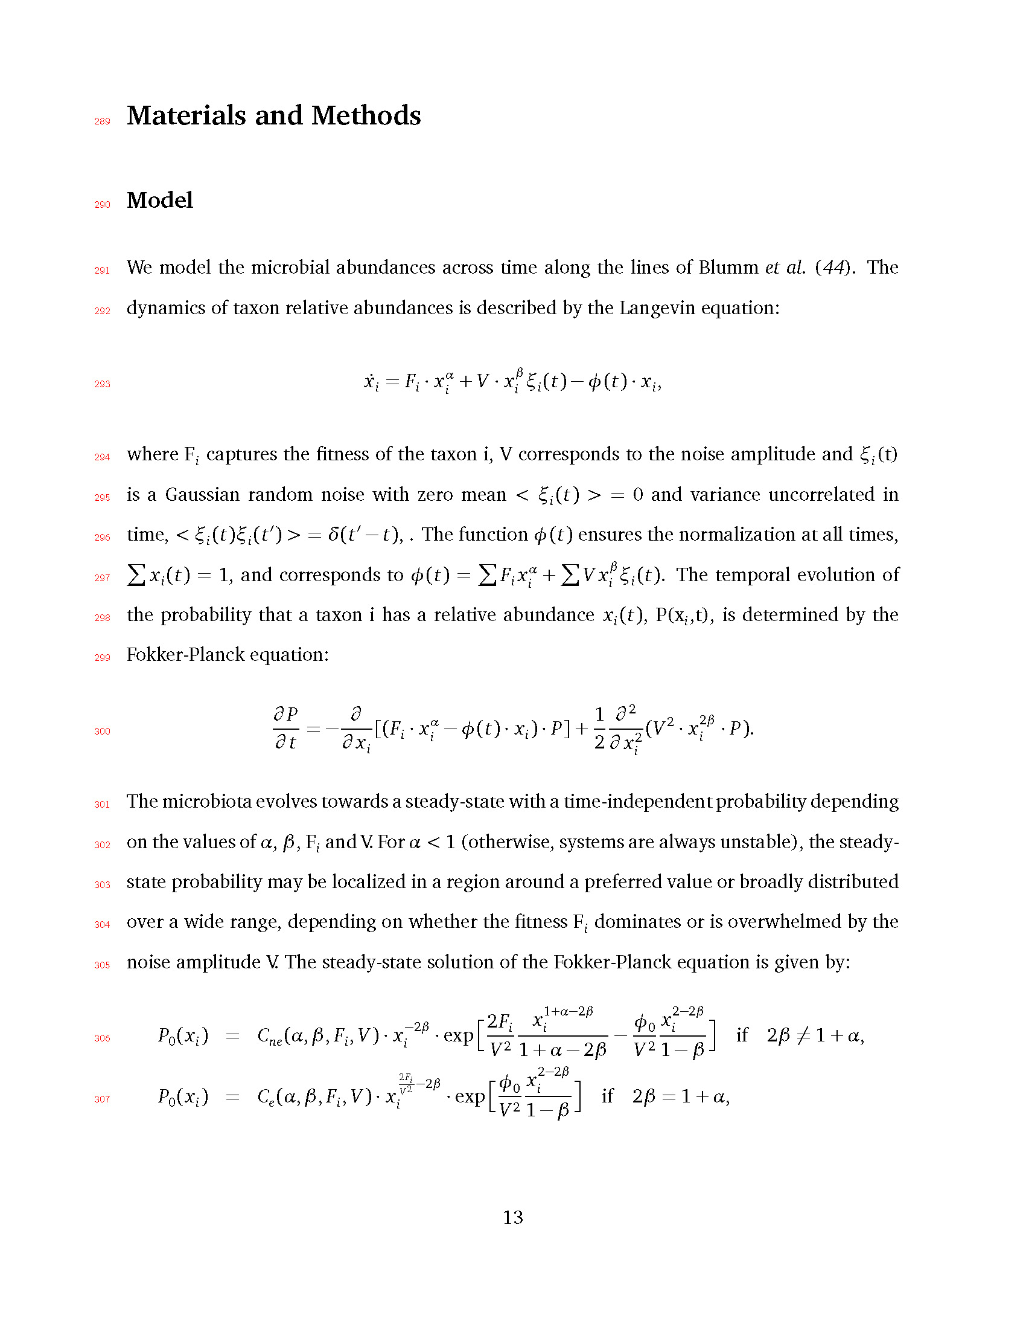

289

# Materials and Methods

290

## Model

291

We model the microbial abundances across time along the lines of Blumm *et al.* (*44*). The

292

*β*

dynamics of taxon relative abundances is described by the Langevin equation:

293

*x*˙*i* = *Fi · xα* + *V · x*

*ξi* (*t*) *− φ*(*t*) *· xi* ,

294

*i*

*i*

295

296

where F*i* captures the fitness of the taxon i, V corresponds to the noise amplitude and *ξi* (t)

is a Gaussian random noise with zero mean *< ξi* (*t*) *> =* 0 and variance uncorrelated in time, *< ξi* (*t*)*ξi* (*tl*) *> = δ*(*tl − t*), . The function *φ*(*t*) ensures the normalization at all times,

*i*

*β*

*i*

297

� *xi* (*t*) = 1, and corresponds to *φ*(*t*) = � *Fi xα* + � *V x*

*ξi* (*t*). The temporal evolution of

298

299

the probability that a taxon i has a relative abundance *xi* (*t*), P(x*i* ,t), is determined by the Fokker-Planck equation:

*∂ P ∂ α*

*i*

1 *∂* 2

2 2*β*

300

*i*

*∂ t* = *−∂ x*

[(*Fi · xi − φ*(*t*) *· xi* ) *· P*] + 2 *∂ x* 2 (*V*

* *xi · P*).

301

302

303

304

305

The microbiota evolves towards a steady-state with a time-independent probability depending on the values of *α*, *β* , F*i* and V. For *α <* 1 (otherwise, systems are always unstable), the steady- state probability may be localized in a region around a preferred value or broadly distributed over a wide range, depending on whether the fitness F*i* dominates or is overwhelmed by the noise amplitude V. The steady-state solution of the Fokker-Planck equation is given by:

306

*P*0(*xi* ) = *Cne* (*α*, *β* , *Fi* , *V* ) *· x−*

* exp r

2*Fi*

1+*α−*2*β*

*i*

*x*

2*−*2*β*

0 *i*

*φ x*

*−*

l if 2*β I*= 1 + *α*,

*i*

2*β*

2 *−*2*β*

*V* 2 1 + *α −* 2*β*

2*−*2*β*

*φ x*

0 *i*

*V* 2 1 *− β*

307

2*Fi*

*P*0(*xi* ) = *Ce* (*α*, *β* , *Fi* , *V* ) *· x V*

*i*

* + exp

r l

*V* 2 1 *− β*

if 2*β* = 1 + *α*,

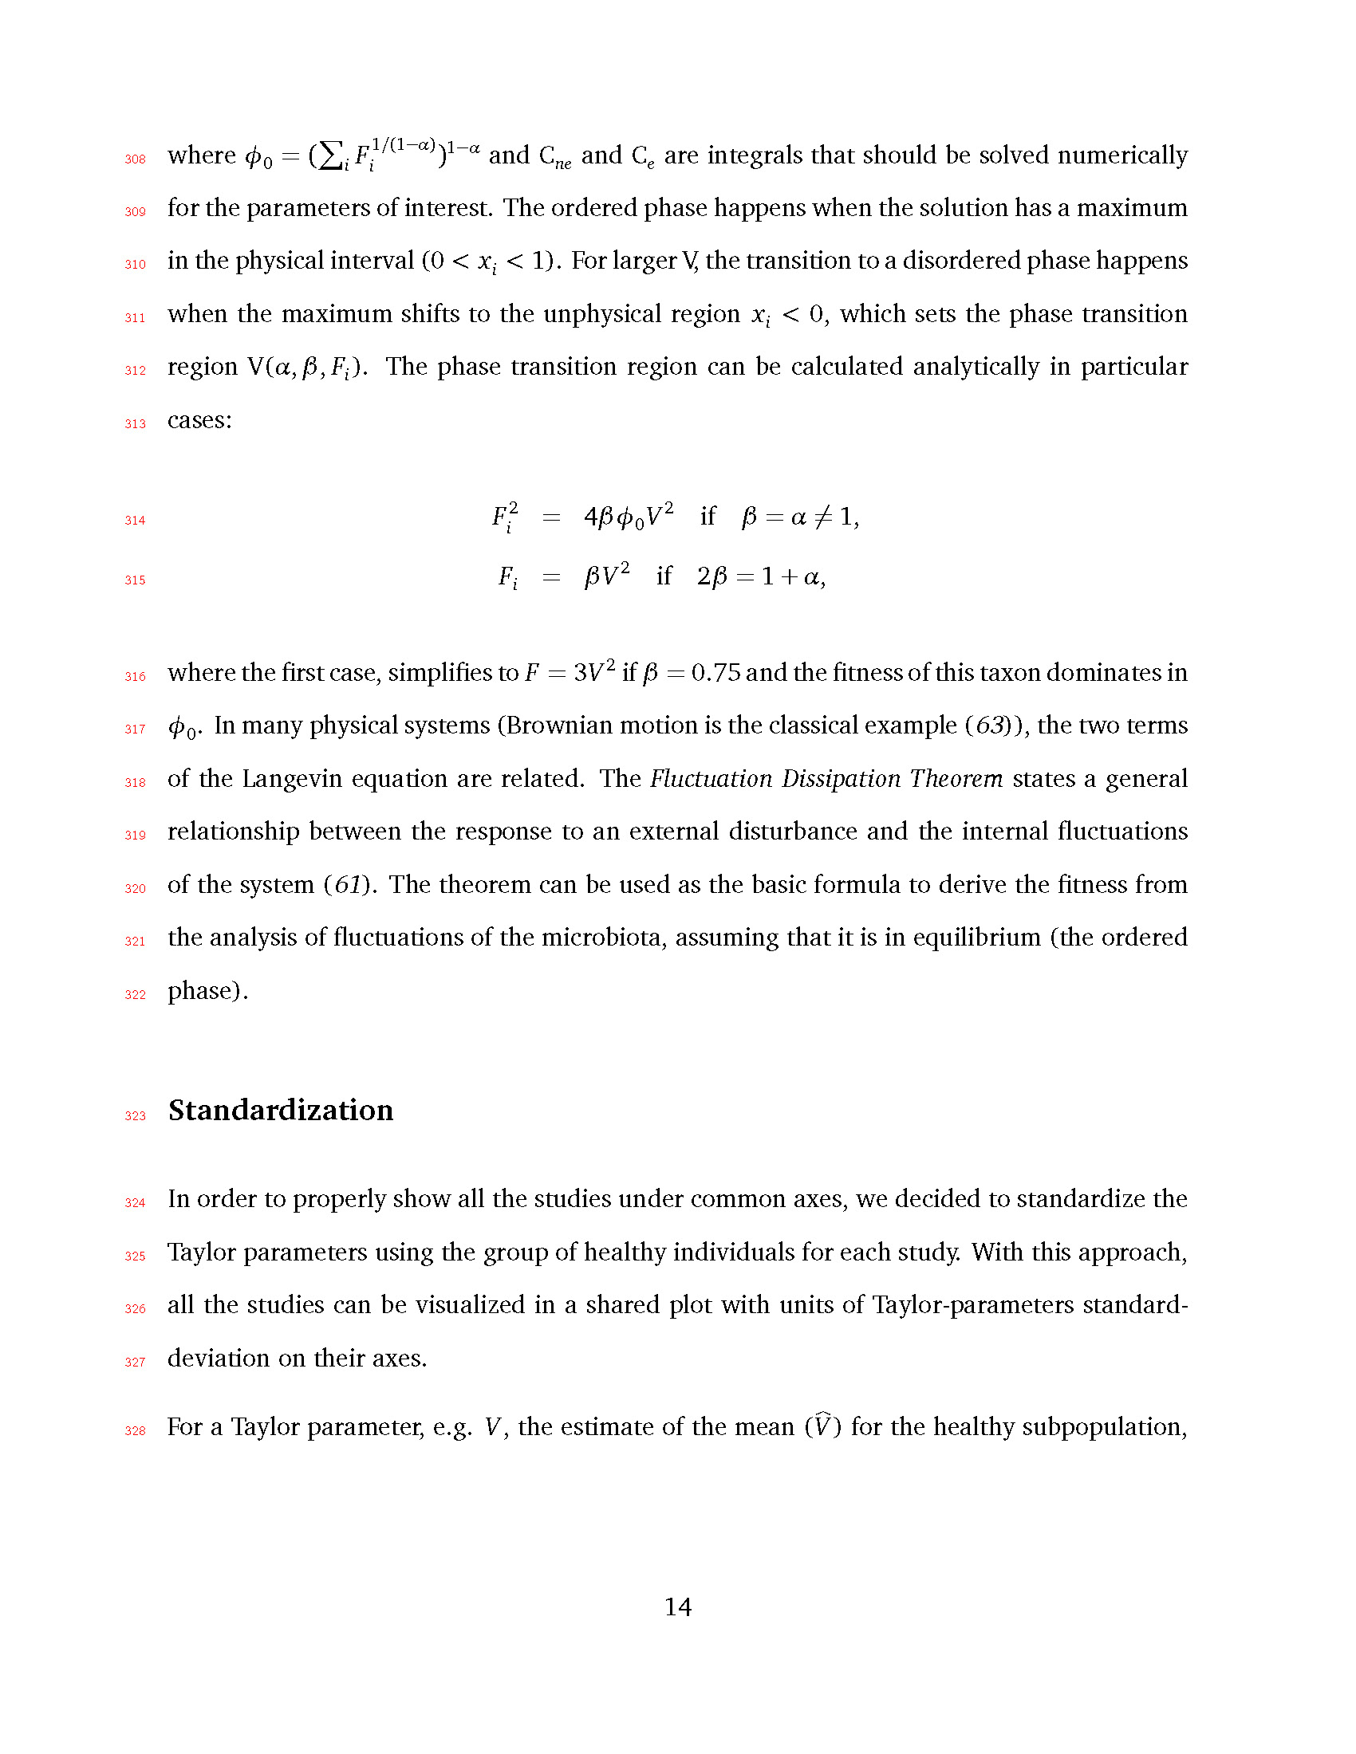

308

where *φ*0 = (�*i Fi* )

1*−α*

and C*ne* and C*e* are integrals that should be solved numerically

309

1*/*(1*−α*)

310

311

312

313

for the parameters of interest. The ordered phase happens when the solution has a maximum in the physical interval (0 *< xi <* 1). For larger V, the transition to a disordered phase happens when the maximum shifts to the unphysical region *xi <* 0, which sets the phase transition

region V(*α*, *β* , *Fi* ). The phase transition region can be calculated analytically in particular

cases:

314

*i* = 4*βφ*0 *V*

if *β* = *α I*= 1,

315

*F* 2

2

*Fi* = *βV* 2 if 2*β* = 1 + *α*,

316

317

318

where the first case, simplifies to *F* = 3*V* 2 if *β* = 0.75 and the fitness of this taxon dominates in *φ*0. In many physical systems (Brownian motion is the classical example (*63*)), the two terms of the Langevin equation are related. The *Fluctuation Dissipation Theorem* states a general

319

relationship between the response to an external disturbance and the internal fluctuations

320

of the system (*61*). The theorem can be used as the basic formula to derive the fitness from

321

the analysis of fluctuations of the microbiota, assuming that it is in equilibrium (the ordered

322

phase).

323

## Standardization

324

In order to properly show all the studies under common axes, we decided to standardize the

325

Taylor parameters using the group of healthy individuals for each study. With this approach,

326

all the studies can be visualized in a shared plot with units of Taylor-parameters standard-

327

deviation on their axes.

328

For a Taylor parameter, e.g. *V* , the estimate of the mean (*V*C ) for the healthy subpopulation,

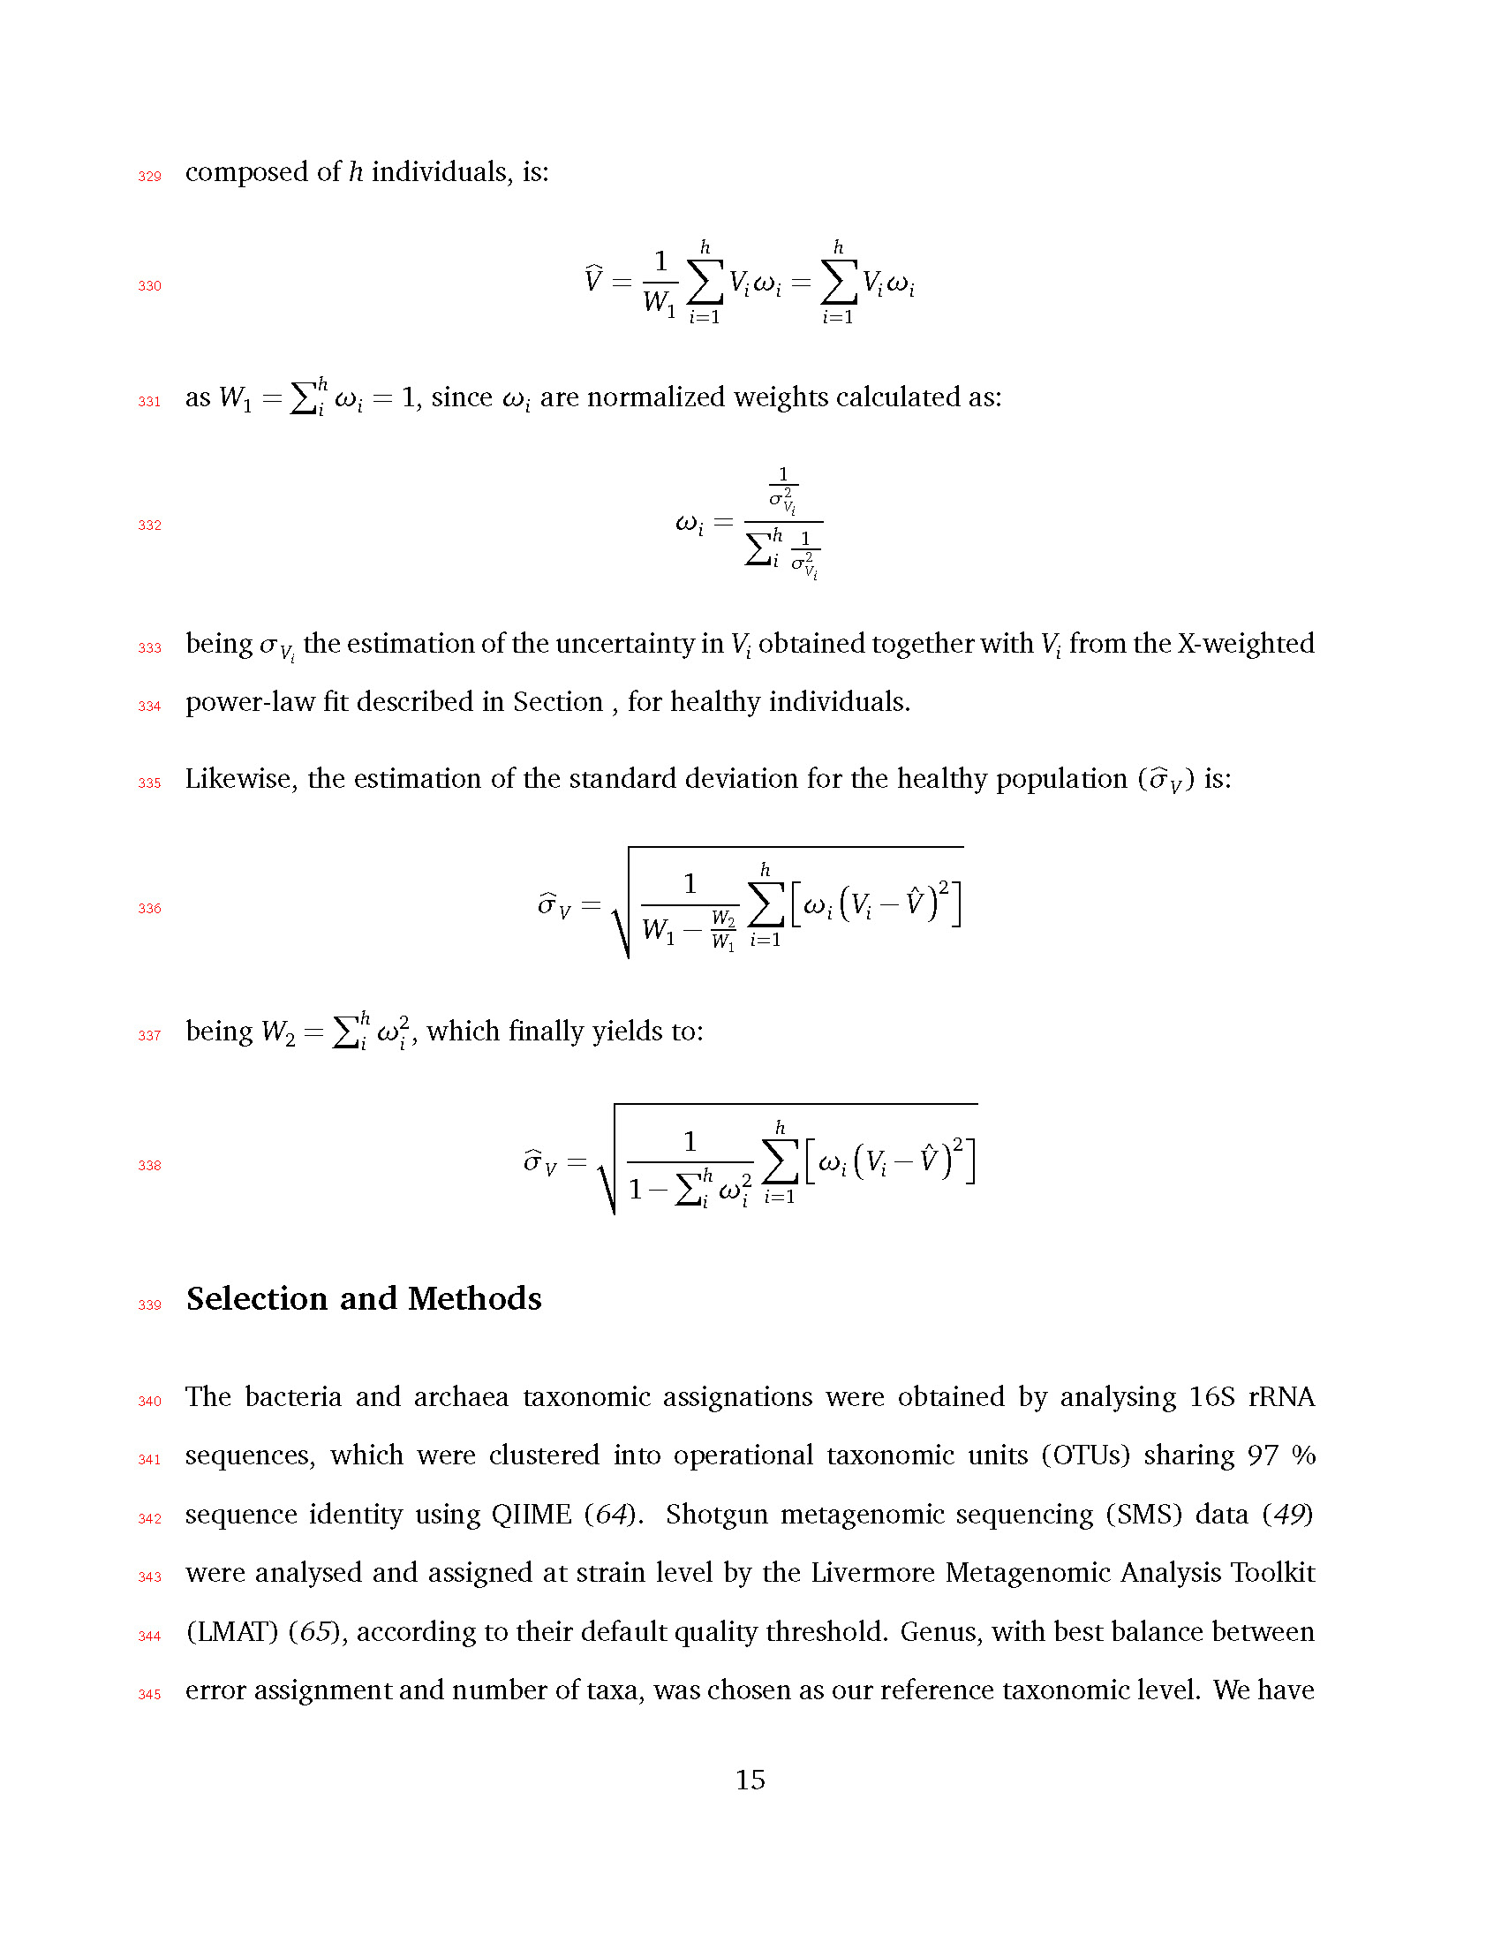

329

composed of *h* individuals, is:

1 *h h*

330

*V* =

*W*

C

*Viωi* =

*Viωi*

1 *i*=1

*i*=1

331

as *W* = �*h ω* = 1, since *ω* are normalized weights calculated as:

332

1

1 *i i i*

*σ*2

*Vi*

*ω* =

*i* �*h* 1

*i σ*2

*Vi*

*i*

333

334

being *σV* the estimation of the uncertainty in *Vi* obtained together with *Vi* from the X-weighted power-law fit described in Section , for healthy individuals.

335

Likewise, the estimation of the standard deviation for the healthy population ( C

) is:

*σV*

1 *h* 2

336

*σ* = r

*ωi Vi − V*ˆ l

C \ *W W*2

*V*

1 *− W*1

*i*=1

*h* 2

337

being *W*2 = �*i ωi* , which finally yields to:

1 *h* 2

338

*σV* =

r

*ωi Vi − V*ˆ l

\ 1 *h* 2

C

*—* �*i ωi*

*i*=1

339

## Selection and Methods

340

The bacteria and archaea taxonomic assignations were obtained by analysing 16S rRNA

341

sequences, which were clustered into operational taxonomic units (OTUs) sharing 97 %

342

sequence identity using QIIME (*64*). Shotgun metagenomic sequencing (SMS) data (*49*)

343

were analysed and assigned at strain level by the Livermore Metagenomic Analysis Toolkit

344

(LMAT) (*65*), according to their default quality threshold. Genus, with best balance between

345

error assignment and number of taxa, was chosen as our reference taxonomic level. We have

346

verified that our conclusions are not significantly affected by selecting family or species as

347

the reference taxonomic level (see Figure 8).

348

### Sample selection

349

We have chosen studies about relevant pathologies containing metagenomic sequencing time

350

data series of bacterial populations from humans in different healthy and non-healthy states.

351

We have selected only those individuals who had three or more time points of data avail-

352

able in databases. Caporaso et al. study (*46*) was selected as it has two healthy individuals

353

measured over a very large timespan, with almost daily sampling. Faith et al. study (*48*)

354

was selected due to the BMI differences between subjects, moreover some of them had diets

355

which can be treated as system perturbations. We considered healthy only those individuals

356

who had normal or overweight BMI. Smith et al., study (*49*) was selected for both the age

357

of the patients and the rare disease. We only worked with the discordant twins, and consid-

358

ered healthy those who were not affected by kwashiorkor in each pair of patients. David et

359

al., study (*50*) was selected for its differential diets. We considered as the healthy part the

360

first time samples of each individual before the diet, and the rest of time points as pertur-

361

bations. Dethlefsen and Relman work (*47*) was selected due to the interesting treatment of

362

two antibiotic intakes of the same antibiotic by three different subjects. We considered as the

363

healthy part only those times before any antibiotic treatment, and as perturbations the time

364

of antibiotic intakes and the period after that. And finally, we also considered a study made

365

in our group carried by Durban et al., (*12*) in which we considered as healthy subjects those

366

who didn’t suffer from irritable bowel disease, and as perturbation the patients who had this

367

disease.

368

Metadata of each study is provided in Supplementary Tables S1 to S4. All used 16S rRNA

369

gene sequencing except for the study of the discordant kwashiorkor twins (*49*), where both

370

SMS and 16S rRNA data were used. In the latter case we selected to work with SMS data to

371

show that our method is valid regardless of the source of taxonomic information. Each one

372

of the datasets was treated as follows:

373

### 16rRNA sequences processing

374

Reads from the selected studies were first quality filtered using the FastX toolkit (*66*), allowing

375

only those reads which had more than 25 of quality along the 75% of the complete sequence.

376

16S rRNA reads were then clustered at 97% nucleotide sequence identity (97% ID) into

377

operational taxonomic units (OTUs) using QIIME package software (*64*) (version 1.8) We

378

followed open reference OTU picking workflow in all cases. The clustering method used was

379

uclust, and the OTUs were matched against Silva database (*67*) (version 111, July 2012)

380

and were assigned to taxonomy with an uclust-based consensus taxonomy assigner. The

381

parameters used in this step were: similarity 0.97, prefilter percent id 0.6, max accepts 20,

382

max rejects 500.

383

### Metagenomic sequences processing

384

Shotgun metagenomic (and 16S too) sequences were analyzed with LMAT (Livermore Metage-

385

nomics Analysis Toolkit) software package (*65*) (version 1.2.4, with Feb’15 release of data

386

base *LMAT-Grand*). LMAT was run using a Bull shared-memory node belonging to the team’s

387

HPC (high performance computing) cluster. It is equipped with 32 cores (64 threads available

388

using Intel Hyper-threading technology) as it has two Haswell-based Xeons (22 nm technol-

389

ogy), the [E5-2698v3@2.3](mailto:E5-2698v3@2.3) GHz, sharing half a tebibyte (0.5 TiB, that is, 512 gibibytes) of

390

391

392

DRAM memory. This node is also provided with a PCIe SSD card as NVRAM, the Micron P420m HHHL, with 1.4 TB, and 750000 reading IOPS, 4 KB, achieving 3.3 GB*/*s. The com- puting node was supplied with a RAID-0 (striping) scratch disk area. We used the “Grand”

393

database (*68*), release Feb’15, provided by the LMAT team, where “Grand” refers to a huge

394

database that contains k-mers from all viral, prokaryote, fungal and protist genomes present

395

in the NCBI database, plus Human reference genome (hg19), plus GenBank Human, plus

396

the 1000 Human Genomes Project (HGP) (this represent about 31.75 billion k-mers occu-

397

pying 457.62 GB) (*68*). Previously to any calculation, the full database was loaded in the

398

399

400

NVRAM. With this configuration the observed LMAT sustained sequence classification rate was 20 kpb/s/core. Finally, it is worth mentioning that a complete set of Python scripts have been developed as back-end and front-end of the LMAT pipeline in order to manage the added

401

complexity of time series analysis.

402

### Taxa level robustness

403

We selected genus as taxonomic level for the subsequent steps of our work. In order to ensure

404

that, between adjacent taxonomic levels, there were not crucial differences which could still

405

be of relevance after standardization (see last subsection of Material and Methods), we tested

406

two different data sets. In the former, the antibiotics study (*47*) with 16S data, we tested the

407

differences between genus and family levels. The latter dataset tested was the kwashiorkor

408

discordant twins study (*49*) for both genus and species taxonomic levels. The Figures 8

409

(overview) and 9 (detail) plot the comparison between studies (and so, 16S and SMS) and

410

between adjacent taxonomic levels.

411

## X-weighted power-law fit

412

When fitting the power-law of std vs. mean, we can take into account that every mean has

413

uncertainty and estimate it for a sample size *n* by the SEM (*Standard Error of the Mean*). Here,

414

the uncertainties affect the independent variable, so the fit is not so trivial as a Y-weighted

415

fit, where the uncertainties affect the dependent variable. A standard approach to do this

416

fit is: a) invert your variables before applying the weights, b) then perform the weighted

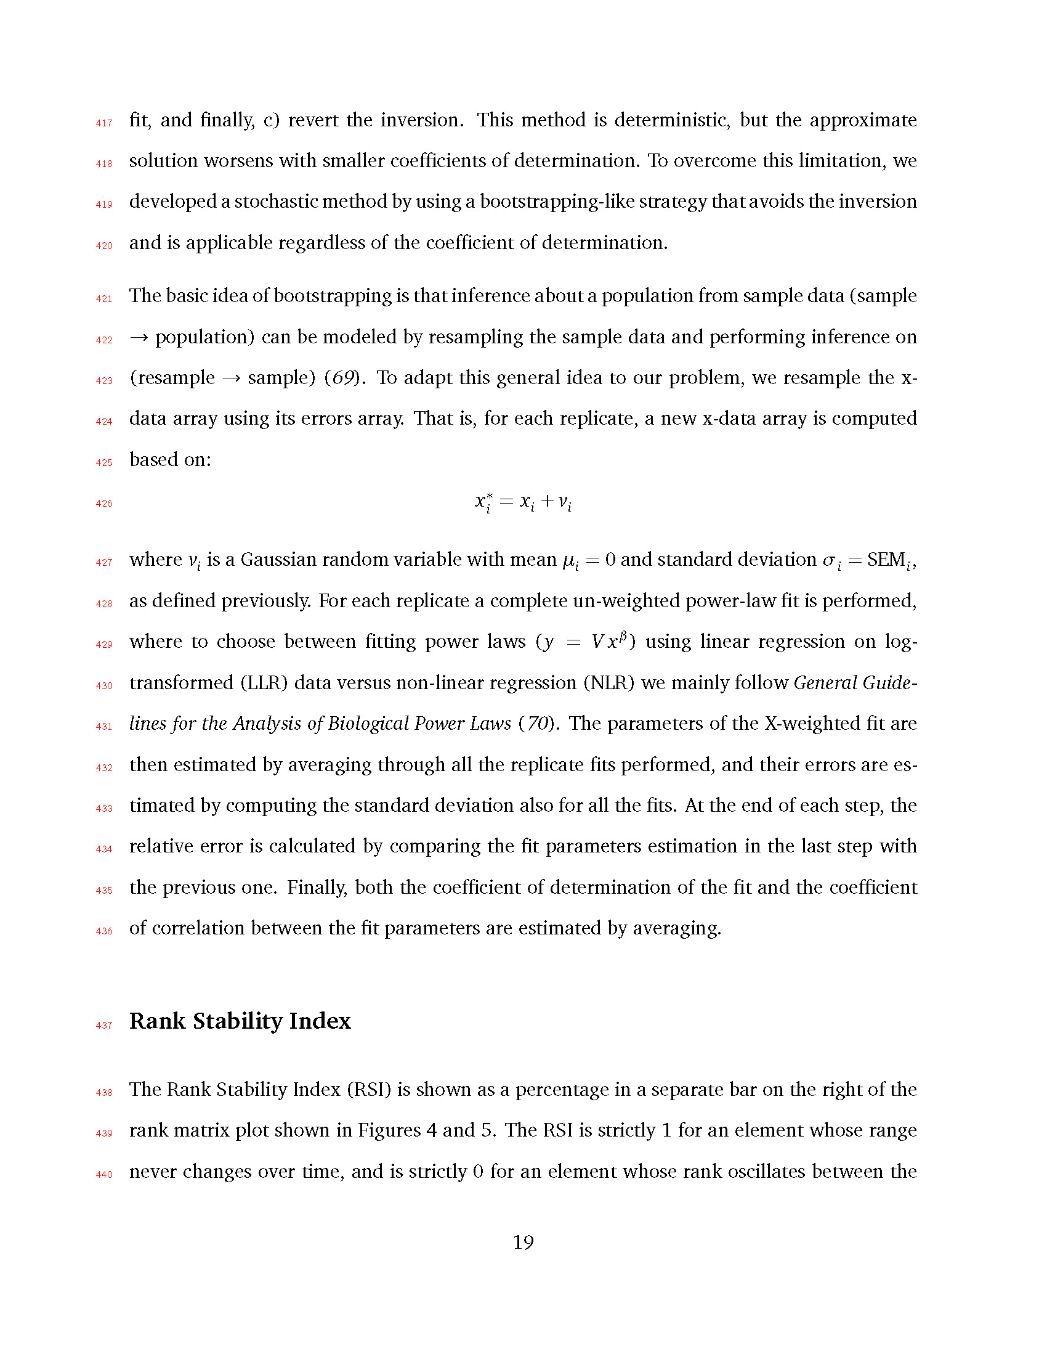

417

fit, and finally, c) revert the inversion. This method is deterministic, but the approximate

418

solution worsens with smaller coefficients of determination. To overcome this limitation, we

419

developed a stochastic method by using a bootstrapping-like strategy that avoids the inversion

420

and is applicable regardless of the coefficient of determination.

421

422

423

424

The basic idea of bootstrapping is that inference about a population from sample data (sample

*→* population) can be modeled by resampling the sample data and performing inference on (resample *→* sample) (*69*). To adapt this general idea to our problem, we resample the x- data array using its errors array. That is, for each replicate, a new x-data array is computed

425

*x∗*

based on:

426

*x*i* = *xi* + *vi*

427

428

429

430

where *vi* is a Gaussian random variable with mean *µi* = 0 and standard deviation *σi* = SEM*i* , as defined previously. For each replicate a complete un-weighted power-law fit is performed, where to choose between fitting power laws ( *y* = *V xβ* ) using linear regression on log- transformed (LLR) data versus non-linear regression (NLR) we mainly follow *General Guide-*

431

*lines for the Analysis of Biological Power Laws* (*70*). The parameters of the X-weighted fit are

432

then estimated by averaging through all the replicate fits performed, and their errors are es-

433

timated by computing the standard deviation also for all the fits. At the end of each step, the

434

relative error is calculated by comparing the fit parameters estimation in the last step with

435

the previous one. Finally, both the coefficient of determination of the fit and the coefficient

436

of correlation between the fit parameters are estimated by averaging.

437

## Rank Stability Index

438

The Rank Stability Index (RSI) is shown as a percentage in a separate bar on the right of the

439

rank matrix plot shown in Figures 4 and 5. The RSI is strictly 1 for an element whose range

440

never changes over time, and is strictly 0 for an element whose rank oscillates between the

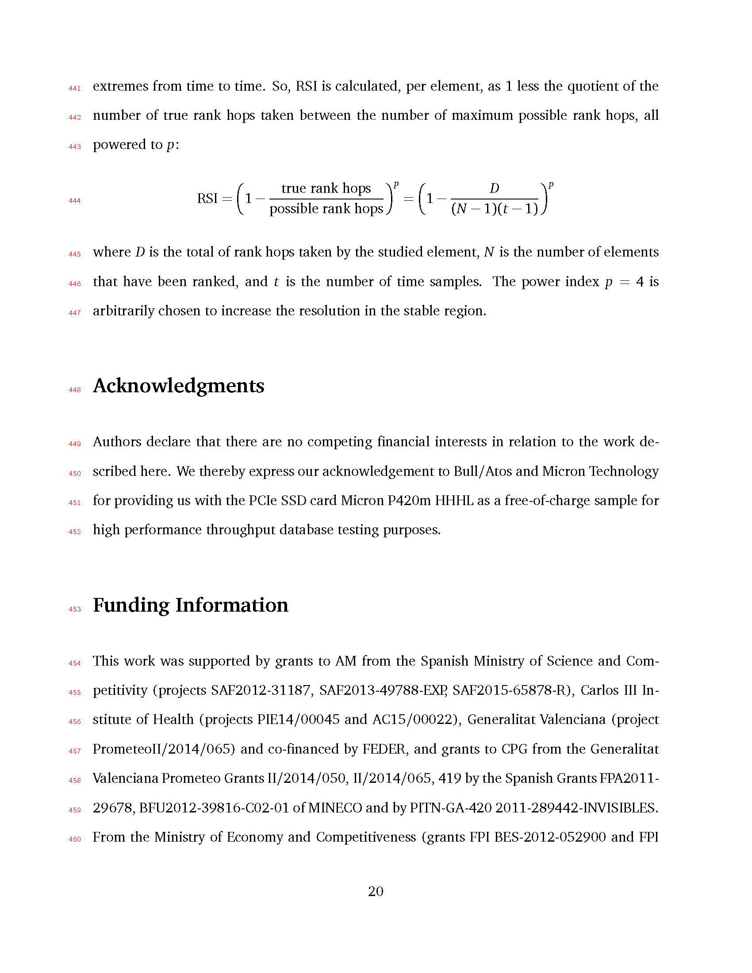

441

extremes from time to time. So, RSI is calculated, per element, as 1 less the quotient of the

442

number of true rank hops taken between the number of maximum possible rank hops, all

443

powered to *p*:

444

RSI =

( true rank hops *p* (

1 *−* possible rank hops = 1 (*N*

*−*

*D*

*−* 1)(*t*

*p*

*−* 1)

445

446

447

where *D* is the total of rank hops taken by the studied element, *N* is the number of elements that have been ranked, and *t* is the number of time samples. The power index *p* = 4 is arbitrarily chosen to increase the resolution in the stable region.

448

# Acknowledgments

449

450

451

Authors declare that there are no competing financial interests in relation to the work de- scribed here. We thereby express our acknowledgement to Bull*/*Atos and Micron Technology for providing us with the PCIe SSD card Micron P420m HHHL as a free-of-charge sample for

452

high performance throughput database testing purposes.

453

# Funding Information

454

This work was supported by grants to AM from the Spanish Ministry of Science and Com-

455

456

457

458

459

petitivity (projects SAF2012-31187, SAF2013-49788-EXP, SAF2015-65878-R), Carlos III In- stitute of Health (projects PIE14*/*00045 and AC15*/*00022), Generalitat Valenciana (project PrometeoII*/*2014*/*065) and co-financed by FEDER, and grants to CPG from the Generalitat Valenciana Prometeo Grants II*/*2014*/*050, II*/*2014*/*065, 419 by the Spanish Grants FPA2011- 29678, BFU2012-39816-C02-01 of MINECO and by PITN-GA-420 2011-289442-INVISIBLES.

460

From the Ministry of Economy and Competitiveness (grants FPI BES-2012-052900 and FPI

461

BES-2013-062767).

462

# References

463

1. **Rosenberg E, Zilber-Rosenberg I.** 2016. Microbes Drive Evolution of Animals and

464

Plants: the Hologenome Concept. MBio **7**:e01395–15–.

465

1. **Bordenstein SR, Theis KR.** 2015. Host Biology in Light of the Microbiome: Ten Prin-

466

ciples of Holobionts and Hologenomes. PLOS Biol **13**:e1002226.

467

1. **Moran NA, Sloan DB.** 2015. The Hologenome Concept: Helpful or Hollow? PLoS Biol

468

**13**:1–10.

469

### Swann JR, Want EJ, Geier FM, Spagou K, Wilson ID, Sidaway JE, Nicholson JK,

470

**Holmes E.** 2011. Systemic gut microbial modulation of bile acid metabolism in host

471

tissue compartments. Proc Natl Acad Sci **108**:4523–4530.

472

1. **Spencer MD, Hamp TJ, Reid RW, Fischer LM, Zeisel SH, Fodor AA.** 2011. Association

473

between composition of the human gastrointestinal microbiome and development of

474

fatty liver with choline deficiency. Gastroenterology **140**:976–986.

475

### Samuel BS, Shaito A, Motoike T, Rey FE, Backhed F, Manchester JK, Hammer RE,

476

**Williams SC, Crowley J, Yanagisawa M, Gordon JI**. 2008. Effects of the gut micro-

477

biota on host adiposity are modulated by the short-chain fatty-acid binding G protein-

478

coupled receptor, Gpr41. Proc Natl Acad Sci **105**:16767–16772.

479

### Smith PM, Howitt MR, Panikov N, Michaud M, Gallini CA, Bohlooly-Y M, Glickman

480

**JN, Garrett WS.** 2013. The Microbial Metabolites, Short-Chain Fatty Acids, Regulate

481

Colonic Treg Cell Homeostasis. Science (80- ) **341**:569–573.

|  |  |  |
| --- | --- | --- |
| 482 | 8. | **Kimura I, Ozawa K, Inoue D, Imamura T, Kimura K, Maeda T, Terasawa K,** |
| 483 |  | **Kashihara D, Hirano K, Tani T, Takahashi T, Miyauchi S, Shioi G, Inoue H, Tsu-** |
| 484 |  | **jimoto G.** 2013. The gut microbiota suppresses insulin-mediated fat accumulation via |
| 485 |  | the short-chain fatty acid receptor GPR43. Nat Commun **4**:1829. |
| 486 | 9. | **Maslowski KM, Vieira AT, Ng A, Kranich J, Sierro F, Di Yu, Schilter HC, Rolph MS,** |
| 487 |  | **Mackay F, Artis D, Xavier RJ, Teixeira MM, Mackay CR.** 2009. Regulation of in- |
| 488 |  | flammatory responses by gut microbiota and chemoattractant receptor GPR43. Nature |
| 489 |  | **461**:1282–1286. |
| 490 | 10. | **Qin J, Li Y, Cai Z, Li S, Zhu J, Zhang F, Liang S, Zhang W, Guan Y, Shen D, Peng Y,** |
| 491 |  | **Zhang D, Jie Z, Wu W, Qin Y, Xue W, Li J, Han L, Lu D, Wu P, Dai Y, Sun X, Li Z, Tang** |
| 492 |  | **A, Zhong S, Li X, Chen W, Xu R, Wang M, Feng Q, Gong M, Yu J, Zhang Y, Zhang** |
| 493 |  | **M, Hansen T, Sanchez G, Raes J, Falony G, Okuda S, Almeida M, LeChatelier E,** |
| 494 |  | **Renault P, Pons N, Batto J-M, Zhang Z, Chen H, Yang R, Zheng W, Li S, Yang H, Wang** |
| 495 |  | **J, Ehrlich SD, Nielsen R, Pedersen O, Kristiansen K, Wang J.** 2012. A metagenome- |
| 496 |  | wide association study of gut microbiota in type 2 diabetes. Nature **490**:55–60. |
| 497 | 11. | **Brown JM, Hazen SL.** 2015. The Gut Microbial Endocrine Organ: Bacterially Derived |
| 498 |  | Signals Driving Cardiometabolic Diseases. Annu Rev Med **66**:343–359. |
| 499 | 12. | **Durbán A, Abellán JJ, Jiménez-Hernández N, Artacho A, Garrigues V, Ortiz V,** |
| 500 |  | **Ponce J, Latorre A, Moya A.** 2013. Instability of the faecal microbiota in diarrhoea- |
| 501 |  | predominant irritable bowel syndrome. FEMS Microbiol Ecol **86**:581–589. |
| 502 | 13. | **Gevers D, Kugathasan S, Denson LA, Vázquez-Baeza Y, Van Treuren W, Ren B,** |
| 503 |  | **Schwager E, Knights D, Song SJ, Yassour M, Morgan XC, Kostic AD, Luo C,** |
| 504 |  | **González A, McDonald D, Haberman Y, Walters T, Baker S, Rosh J, Stephens M,** |
| 505 |  | **Heyman M, Markowitz J, Baldassano R, Griffiths A, Sylvester F, Mack D, Kim S,** |
| 506 |  | **Crandall W, Hyams J, Huttenhower C, Knight R, Xavier RJ.** 2014. The treatment- |

|  |  |  |
| --- | --- | --- |
| 507 |  | naive microbiome in new-onset Crohn’s disease. Cell Host Microbe **15**:382–392. |
| 508 | 14. | **Ridaura VK, Faith JJ, Rey FE, Cheng J, Duncan AE, Kau L, Griffi NW, Lombard V,** |
| 509 |  | **Henrissat B, Bain JR, Michael J, Ilkayeva O, Semenkovich CF, Funai K, Hayashi** |
| 510 |  | **DK, Lyle J, Martini MC, Ursell LK, Clemente JC, Treuren W Van, William A, Knight** |
| 511 |  | **R, Newgard CB, Heath AC, Gordon JI, Kau AL, Griffin NW, Muehlbauer MJ.** 2013. |
| 512 |  | Gut Microbiota from Twins Discordant for Obesity Modulate Metabolism in Mice Gut |
| 513 |  | Microbiota from Twins Metabolism in Mice. Science **341**:1241214. |
| 514 | 15. | **Turnbaugh PJ, Hamady M, Yatsunenko T, Cantarel BL, Duncan A, Ley RE, Sogin** |
| 515 |  | **ML, Jones WJ, Roe BA, Affourtit JP, Egholm M, Henrissat B, Heath AC, Knight R,** |
| 516 |  | **Gordon JI.** 2009. LETTERS A core gut microbiome in obese and lean twins. Nature |
| 517 |  | **457**:480–484. |
| 518 | 16. | **Subramanian S, Huq S, Yatsunenko T, Haque R, Mahfuz M, Alam MA, Benezra** |
| 519 |  | **A, DeStefano J, Meier MF, Muegge BD, Barratt MJ, VanArendonk LG, Zhang Q,** |
| 520 |  | **Province MA, Petri WA, Ahmed T, Gordon JI.** 2014. Persistent gut microbiota imma- |
| 521 |  | turity in malnourished Bangladeshi children. Nature **510**:417–21. |
| 522 | 17. | **Moya A, Ferrer M.** 2016. Functional Redundancy-Induced Stability of Gut Microbiota |
| 523 |  | Subjected to Disturbance. Trends Microbiol **24**:402–413. |
| 524 | 18. | **Cryan JF, Dinan TG**. 2012. Mind-altering microorganisms: the impact of the gut mi- |
| 525 |  | crobiota on brain and behaviour. Nat Rev Neurosci **13**:701–712 |
| 526 | 19. | **Xu R, Wang Q**. 2016. Towards understanding brain-gut-microbiome connections in |
| 527 |  | Alzheimer’s disease. BMC Systems Biology **10**:277-285 |
| 528 | 20. | **Giloteaux L, Goodrich JK, Walters WA, Levine SM, Ley RE, Hanson MR**. 2016. |
| 529 |  | Reduced diversity and altered composition of the gut microbiome in individuals with |
| 530 |  | myalgic encephalomyelitis*/*chronic fatigue syndrome. Microbiome. **4**:30 |

|  |  |  |
| --- | --- | --- |
| 531 | 21. | **Marchesi JR, Adams DH, Fava F, Hermes GD a, Hirschfield GM, Hold G, Quraishi** |
| 532 |  | **MN, Kinross J, Smidt H, Tuohy KM, Thomas L V, Zoetendal EG, Hart A.** 2015. The |
| 533 |  | gut microbiota and host health: a new clinical frontier. Gut 1–10. |
| 534 | 22. | **Falony G, Joossens M, Vieira-Silva S, Wang J, Darzi Y, Faust K, Kurilshikov A, Bon-** |
| 535 |  | **der MJ, Valles-Colomer M, Vandeputte D, Tito RY, Chaffron S, Rymenans L, Ver-** |
| 536 |  | **specht C, De Sutter L, Lima-Mendez G, Dhoe K, Jonckheere K, Homola D, Garcia** |
| 537 |  | **R, Tigchelaar EF, Eeckhaudt L, Fu J, Henckaerts L, Zhernakova A, Wijmenga C,** |
| 538 |  | **Raes J.** 2016. Population-level analysis of gut microbiome variation. Science (80- ) |
| 539 |  | **352**:560–564. |
| 540 | 23. | **Zhernakova A, Kurilshikov A, Bonder MJ, Tigchelaar EF, Schirmer M, Vatanen** |
| 541 |  | **T, Mujagic Z, Vila AV, Falony G, Vieira-Silva S, Wang J, Imhann F, Brandsma E,** |
| 542 |  | **Jankipersadsing SA, Joossens M, Cenit MC, Deelen P, Swertz MA, Weersma RK,** |
| 543 |  | **Feskens EJM, Netea MG, Gevers D, Jonkers D, Franke L, Aulchenko YS, Hutten-** |
| 544 |  | **hower C, Raes J, Hofker MH, Xavier RJ, Wijmenga C, Fu J.** 2016. Population-based |
| 545 |  | metagenomics analysis reveals markers for gut microbiome composition and diversity. |
| 546 |  | Science (80- ) **352**:565–569. |
| 547 | 24. | **Amato KR** 2016. Incorporating the Gut Microbiota Into Models of Human and |
| 548 |  | Non-Human Primate Ecology and Evolution. Yearbook Of Physical Anthropology |
| 549 |  | **157**:S196–S215. |
| 550 | 25. | **Wu H, Tremaroli V, Bäckhed F.** 2015. Linking Microbiota to Human Diseases: A Sys- |
| 551 |  | tems Biology Perspective. Trends Endocrinol Metab **26**:758–770. |
| 552 | 26. | **Noecker C, Eng A, Srinivasan S, Theriot CM, Young VB, Jansson JK, Fredricks** |
| 553 |  | **DN, Borenstein E.** 2016. Metabolic Model-Based Integration of Microbiome Taxo- |
| 554 |  | nomic and Metabolomic Profiles Elucidates Mechanistic Links between Ecological and |
| 555 |  | Metabolic Variation. mSystems **1**:e00013–15. |

556

1. **Greenblum S, Turnbaugh PJ, Borenstein E.** 2012. Metagenomic systems biology of

557

the human gut microbiome reveals topological shifts associated with obesity and in-

558

flammatory bowel disease. Proc Natl Acad Sci **109**:594–599.

559

### Bashan A, Gibson TE, Friedman J, Carey VJ, Weiss ST, Hohmann EL, Liu Y-Y. 2016.

560

Universality of human microbial dynamics. Nature **534**:259–262.

561

1. **Taylor, L.R.** 1961. Aggregation, Variance and the mean. Nature **189,** 732-35.

562

1. **de Menezes MA, Barabási A-L.** 2004. Fluctuations in network dynamics. Phys Rev

563

Lett **92**:1–4.

564

1. **Mantegna RN, Stanley HE.** 1995. Scaling behaviour in the dynamics of an economic

565

index. Nature **376**:46–49.

566

1. **Eisler Z, Kertesz J, Yook SH, Barabasi AL.** 2005. Multiscaling and non-universality

567

in fluctuations of driven complex systems. Europhys Lett **69**:664–670.

568

1. **Cohen JE, Xu M, Schuster WSF**. 2013. Stochastic multiplicative population growth

569

predicts and interprets Taylor’s power law of fluctuation scaling. Proc R Soc B Biol Sci

570

**280**:20122955.

571

1. **Reed DH, Hobbs GR.** 2004. The relationship between population size and temporal

572

variability in population size. Anim Conserv **7**:1–8.

573

1. **Anderson RM, Gordon DM, Crawley MJ, Hassell MP.** 1982. Variability in the abun-

574

dance of animal and plant species. Nature **18**: 245–248

575

1. **Živkovi´c J, Tadi´c B, Wick N, Thurner S.** 2006. Statistical indicators of collective be-

576

havior and functional clusters in gene networks of yeast. Eur Phys J B **50**:255–258.

577

1. **Kendal WS.** 2003. An Exponential Dispersion Model for the Distribution of Human

578

Single Nucleotide Polymorphisms. Mol Biol Evol **20**:579–590.

579

1. **Zhang Z, Geng J, Tang X, Fan H, Xu J, Wen X, Ma ZS, Shi P.** 2014. Spatial het-

580

erogeneity and co-occurrence patterns of human mucosal-associated intestinal micro-

581

biota. ISME J **8**:881–93.

582

1. **Kaltz O, Escobar-Paramo P, Hochberg M, Cohen** JE. 2012. Bacterial microcosmos

583

obey Taylor’s law: Effects of abiotic and biotic stress and genetics on mean and variance

584

of population density. Ecol Process **1**:5.

585

1. **Ramsayer J, Fellous S, Cohen JE, Hochberg ME.** 2012. Taylor’s Law holds in exper-

586

imental bacterial populations but competition does not influence the slope. Biol Lett

587

**8**:316–319.

588

### Pérez-Cobas AE, Artacho A, Ott SJ, Moya A, Gosalbes MJ, Latorre A. 2014. Struc-

589

tural and functional changes in the gut microbiota associated to Clostridium difficile

590

infection. Front Microbiol **5**:1–15.

591

1. **Ding T, Schloss PD.** 2014. Dynamics and associations of microbial community types

592

across the human body. Nature **509**:357–360.

593

### Gajer P, Brotman RM, Bai G, Sakamoto J, Schütte UME, Zhong X, Koenig SSK, Fu L,

594

**Ma ZS, Zhou X, Abdo Z, Forney LJ, Ravel J.** 2012. Temporal dynamics of the human

595

vaginal microbiota. Sci Transl Med **4**:132ra52.

596

### Blumm N, Ghoshal G, Forró Z, Schich M, Bianconi G, Bouchaud J-P, Barabási A-L.

597

2012. Dynamics of Ranking Processes in Complex Systems. Phys Rev Lett **109**:128701.

598

1. **Eisler Z, Bartos I, Kertész J.** 2008. Fluctuation scaling in complex systems: Taylor’s

599

law and beyond1. Adv Phys **57**:89–142.

600

### Caporaso JG, Lauber CL, Costello EK, Berg-Lyons D, Gonzalez A, Stombaugh J,

601

**Knights D, Gajer P, Ravel J, Fierer N, Gordon JI, Knight R.** 2011. Moving pictures

602

of the human microbiome. Genome Biol **12**:R50.

603

1. **Dethlefsen L, Relman DA.** 2011. Incomplete recovery and individualized responses

604

of the human distal gut microbiota to repeated antibiotic perturbation. Proc Natl Acad

605

Sci **108**:4554–61.

606

### Faith JJ, Guruge JL, Charbonneau M, Subramanian S, Seedorf H, Goodman AL,

607

### Clemente JC, Knight R, Heath AC, Leibel RL, Rosenbaum M, Gordon JI. 2013. The

608

long-term stability of the human gut microbiota. Science **341**:1237439.

609

### Smith MI, Yatsunenko T, Manary MJ, Trehan I, Mkakosya R, Cheng J, Kau AL, Rich

610

### SS, Concannon P, Mychaleckyj JC, Liu J, Houpt E, Li J V, Holmes E, Nicholson J,

611

**Knights D, Ursell LK, Knight R, Gordon JI.** 2013. Gut microbiomes of Malawian twin

612

pairs discordant for kwashiorkor. Science **339**:548–54.

613

### David LA, Maurice CF, Carmody RN, Gootenberg DB, Button JE, Wolfe BE, Ling A V,

614

### Devlin AS, Varma Y, Fischbach MA, Biddinger SB, Dutton RJ, Turnbaugh PJ. 2014.

615

Diet rapidly and reproducibly alters the human gut microbiome. Nature **505**:559–63.

616

1. **Jørgensen B, Martinez JR, Tsao M.** 1994. Asymptotic behaviour of the variance func-

617

tion. Scand J Stat **21**:223–243.

618

1. **Fronczak A, Fronczak P.** 2010. Origins of Taylor’s power law for fluctuation scaling in

619

complex systems. Phys Rev E **81**:066112.

620

1. **Kendal, W.S., Jorgensen,B.** Taylor’s power law and fluctuation scaling explained by a

621

central-limit-like convergence. Phys. Rev. E **83** 066115.

622

623

1. **Kendal WS, Jørgensen B.** 2011. Tweedie convergence: A mathematical basis for Tay- lor’s power law, 1*/*f noise, and multifractality. Phys Rev E **84**:066120.

624

1. **Kilpatrick a M, Ives a R.** 2003. Species interactions can explain Taylor’s power law

625

for ecological time series. Nature **422**:65–68.

626

1. **Ballantyne IV F, J. Kerkhoff A.** 2007. The observed range for temporal mean-variance

627

scaling exponents can be explained by reproductive correlation. Oikos **116**:174–180.

628

### Stein RR, Bucci V, Toussaint NC, Buffie CG, Rätsch G, Pamer EG, Sander C, Xavier

629

**JB.** 2013. Ecological modeling from time-series inference: insight into dynamics and

630

stability of intestinal microbiota. PLoS Comput Biol **9**:e1003388.

631

1. **Fisher CK, Mehta P.** 2014. Identifying keystone species in the human gut microbiome

632

from metagenomic timeseries using sparse linear regression. PLoS One **9**:e102451.

633

### Bucci V, Tzen B, Li N, Simmons M, Tanoue T, Bogart E, Deng L, Yeliseyev V, Delaney

634

**ML, Liu Q, Olle B, Stein RR, Honda K, Bry L, Gerber GK.** 2016. MDSINE: Microbial

635

Dynamical Systems INference Engine for microbiome time-series analyses. Genome

636

Biol **17**:121.

637

### Koenig JE, Spor A, Scalfone N, Fricker AD, Stombaugh J, Knight R, Angenent LT,

638

**Ley RE.** 2011. Succession of microbial consortia in the developing infant gut micro-

639

biome. Proc Natl Acad Sci **108**:4578–4585.

640

1. **Weber, J.** 1956. Fluctuation Dissipation Theorem. Phys. Rev. **101**:1620-6

641

1. **Tikhonov M.** 2016. Community-level cohesion without cooperation. Elife **5**.

642

1. **Einstein A.** 1905. Über die von der molekularkinetischen Theorie der Wärme

643

geforderte Bewegung von in ruhenden Flüssigkeiten suspendierten Teilchen. Annalen

644

der Physik, **322**:549-560.

645

### Caporaso JG, Kuczynski J, Stombaugh J, Bittinger K, Bushman FD, Costello EK,

646

### Fierer N, Peña AG, Goodrich JK, Gordon JI, Huttley G a, Kelley ST, Knights D,

647

### Koenig JE, Ley RE, Lozupone C a, Mcdonald D, Muegge BD, Pirrung M, Reeder J,

648

### Sevinsky JR, Turnbaugh PJ, Walters W a, Widmann J, Yatsunenko T, Zaneveld J,

649

**Knight R.** 2010. correspondence QIIME allows analysis of high- throughput commu-

650

nity sequencing data Intensity normalization improves color calling in SOLiD sequenc-

651

ing. Nat Publ Gr **7**:335–336.

652

1. **Ames SK, Hysom DA, Gardner SN, Lloyd GS, Gokhale MB, Allen JE**. 2013. Scalable

653

metagenomic taxonomy classification using a reference genome database. Bioinfor-

654

matics **29**:2253-2260.

655

656

1. **Gordon, A, Hannon, GJ.** 2010. FASTX-Toolkit. FASTQ*/*A shortreads pre-processing tools v0.0.13. [http:*//*hannonlab.cshl.edu*/*fastx_toolkit*/*](http://hannonlab.cshl.edu/fastx_toolkit/)(last accessed 26 Jul 2016).

657

### Quast C, Pruesse E, Yilmaz P, Gerken J, Schweer T, Yarza P, Peplies J, Glöckner FO.

658

2013. The SILVA ribosomal RNA gene database project: improved data processing and

659

web-based tools. Acids Res. **41**:D590-D596

660

### Ames SK, Gardner SN, Marti JM, Slezak TR, Gokhale MB, Allen JE. 2015. Using

661

populations of human and microbial genomes for organism detection in metagenomes.

662

Genome Res. **25**:1056-67.

663

1. **Wu, C.F.J.** 1986. Jackknife, bootstrap and other resampling methods in regression anal-

664

ysis. (with discussions) *The Annals of Statistics* **14**:1261-1350

665

1. **Xiao X, White EP, Hooten MB, Durham SL**. 2011. On the use of log-transformation

666

vs. nonlinear regression for analyzing biological power laws. Ecology **92**:1887-1894

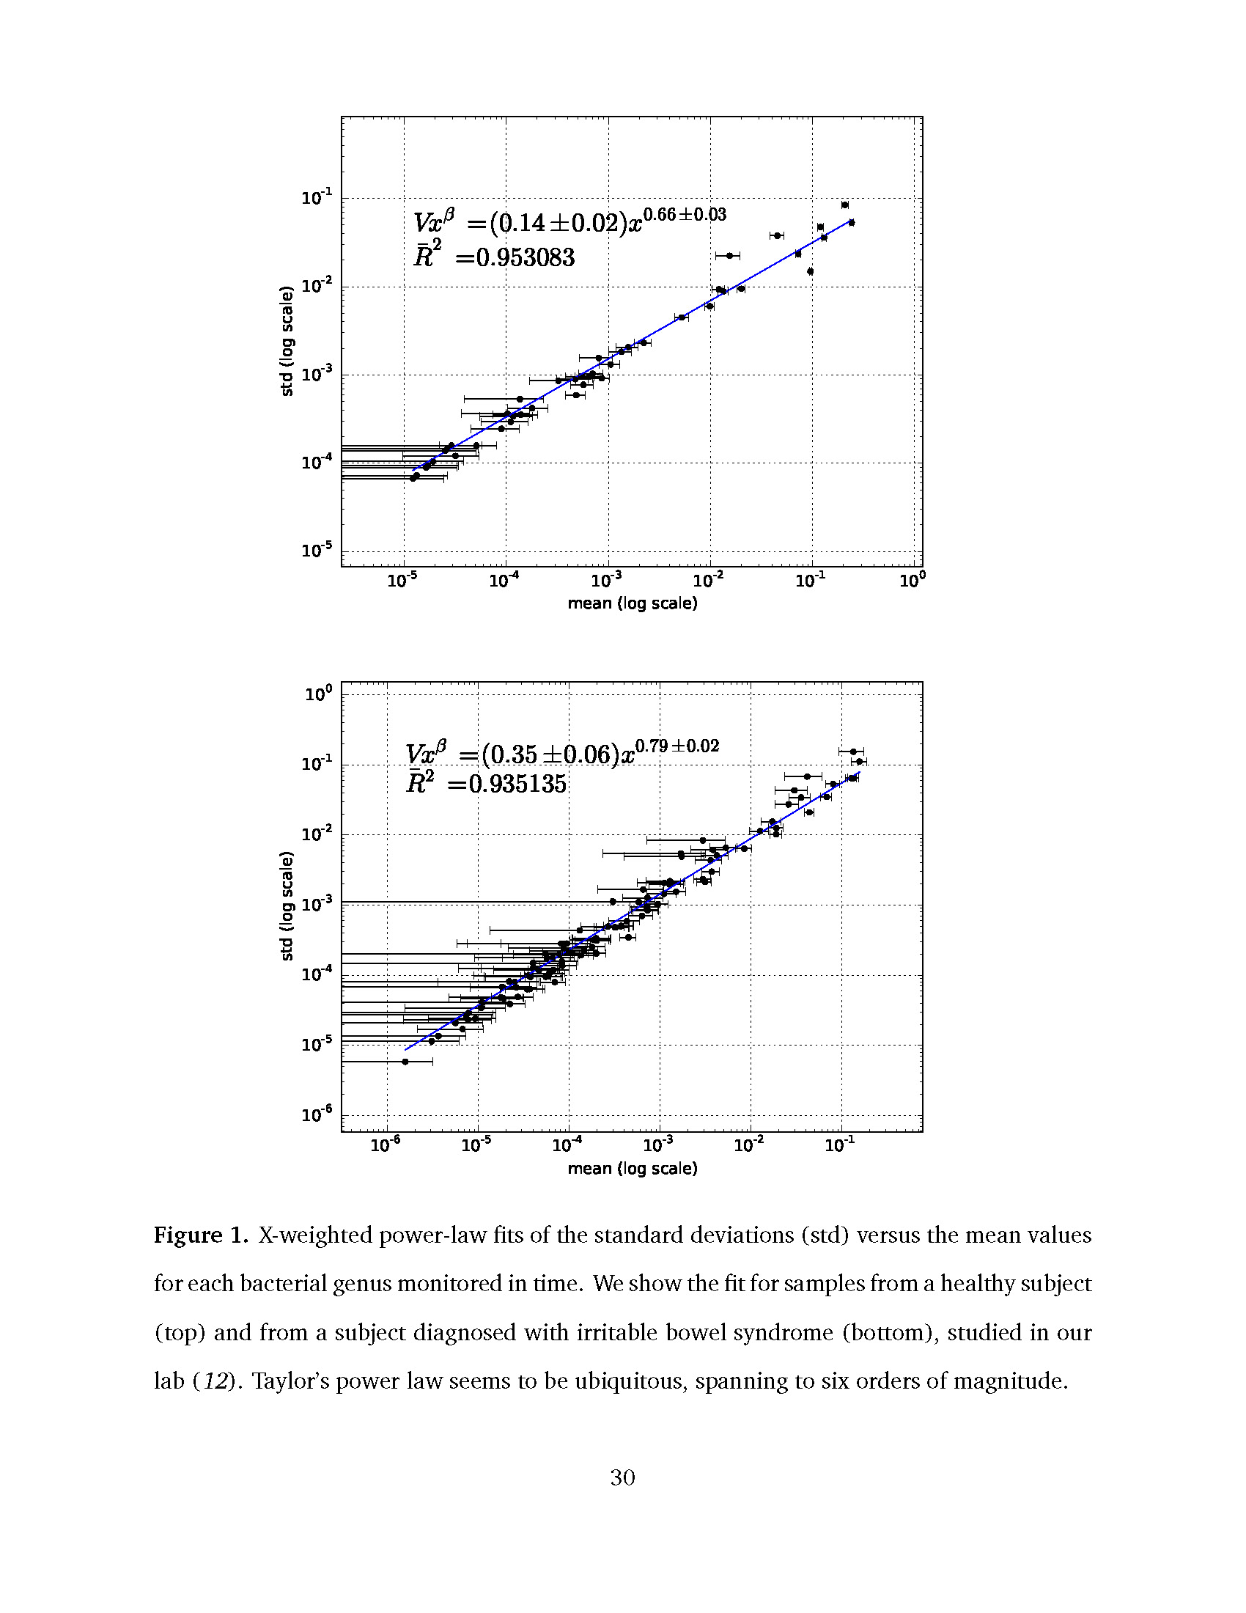.

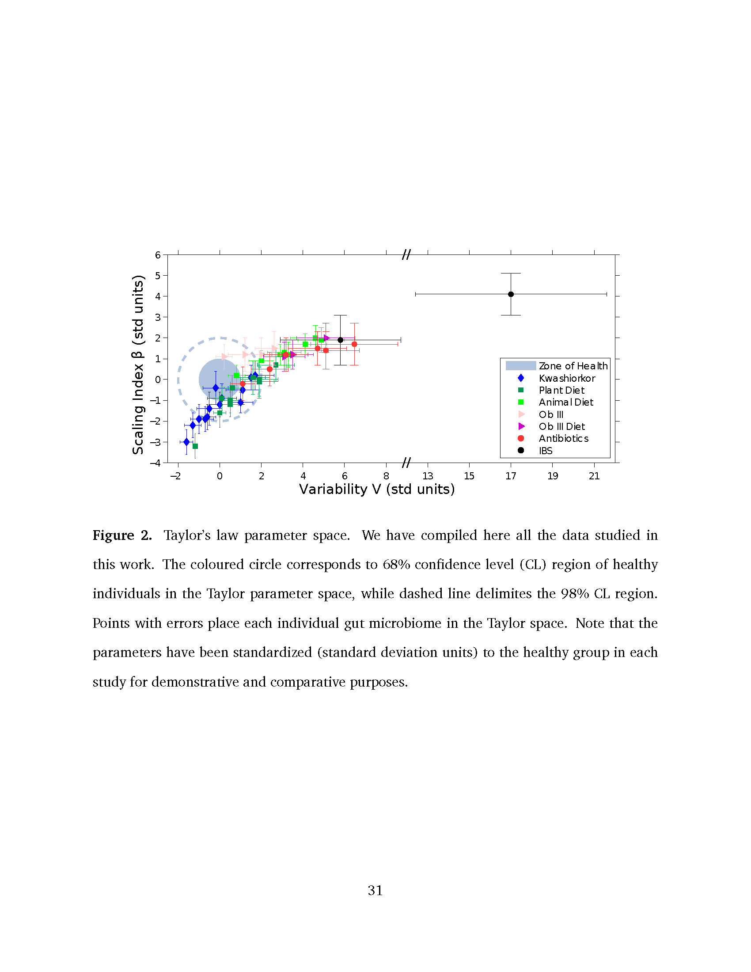

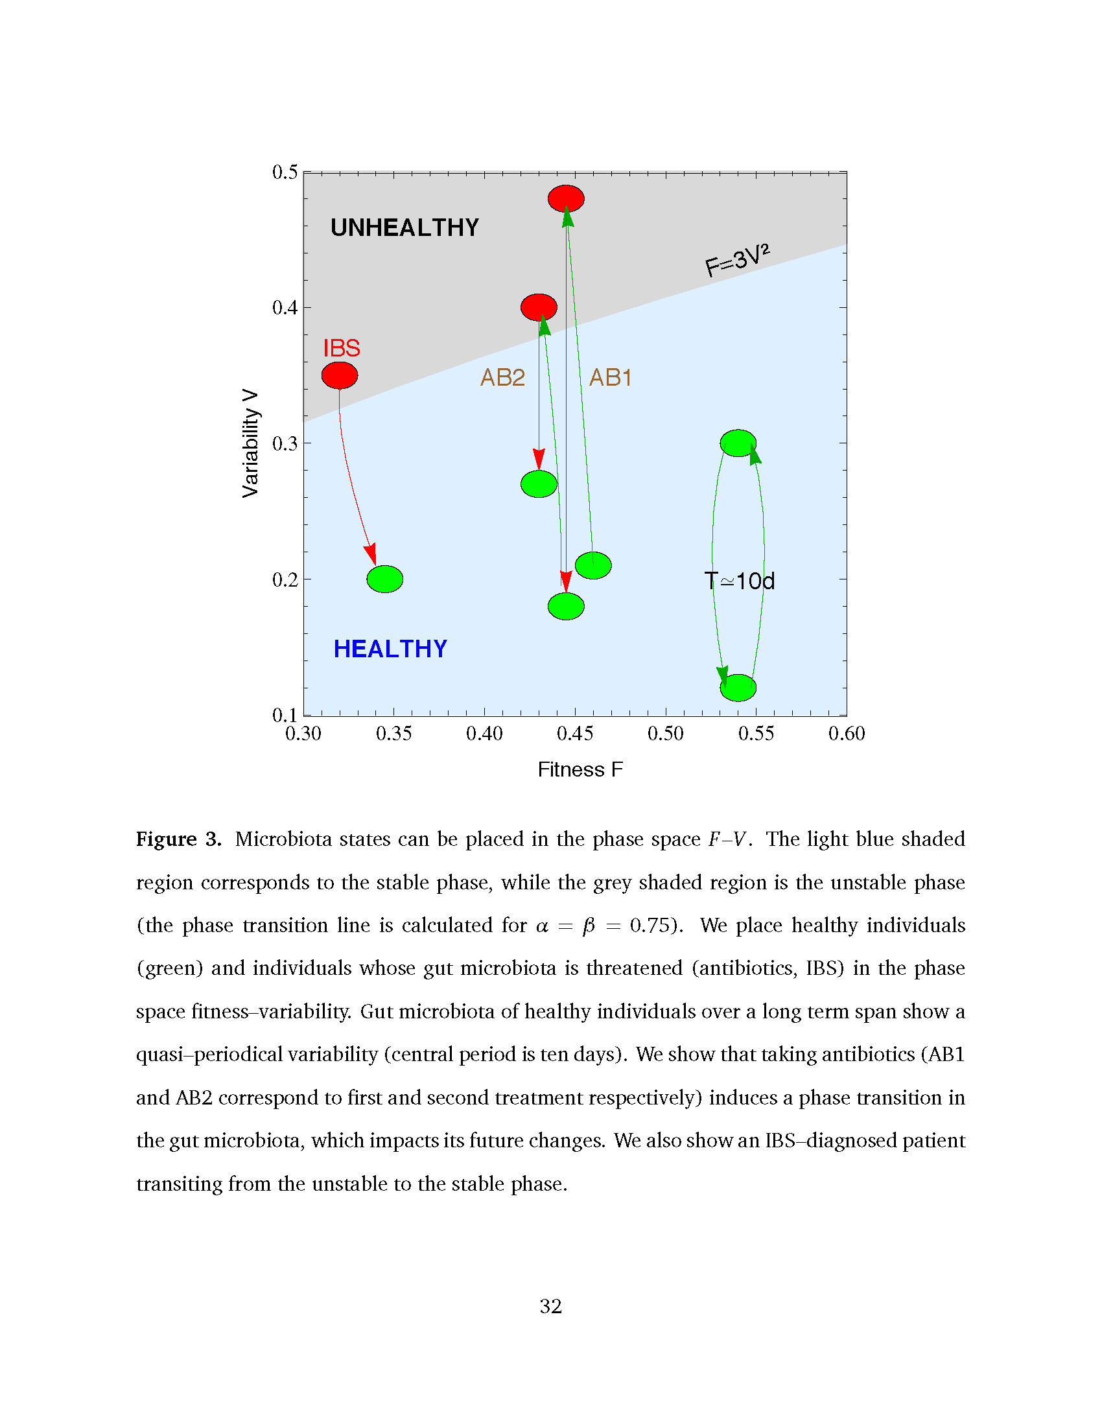

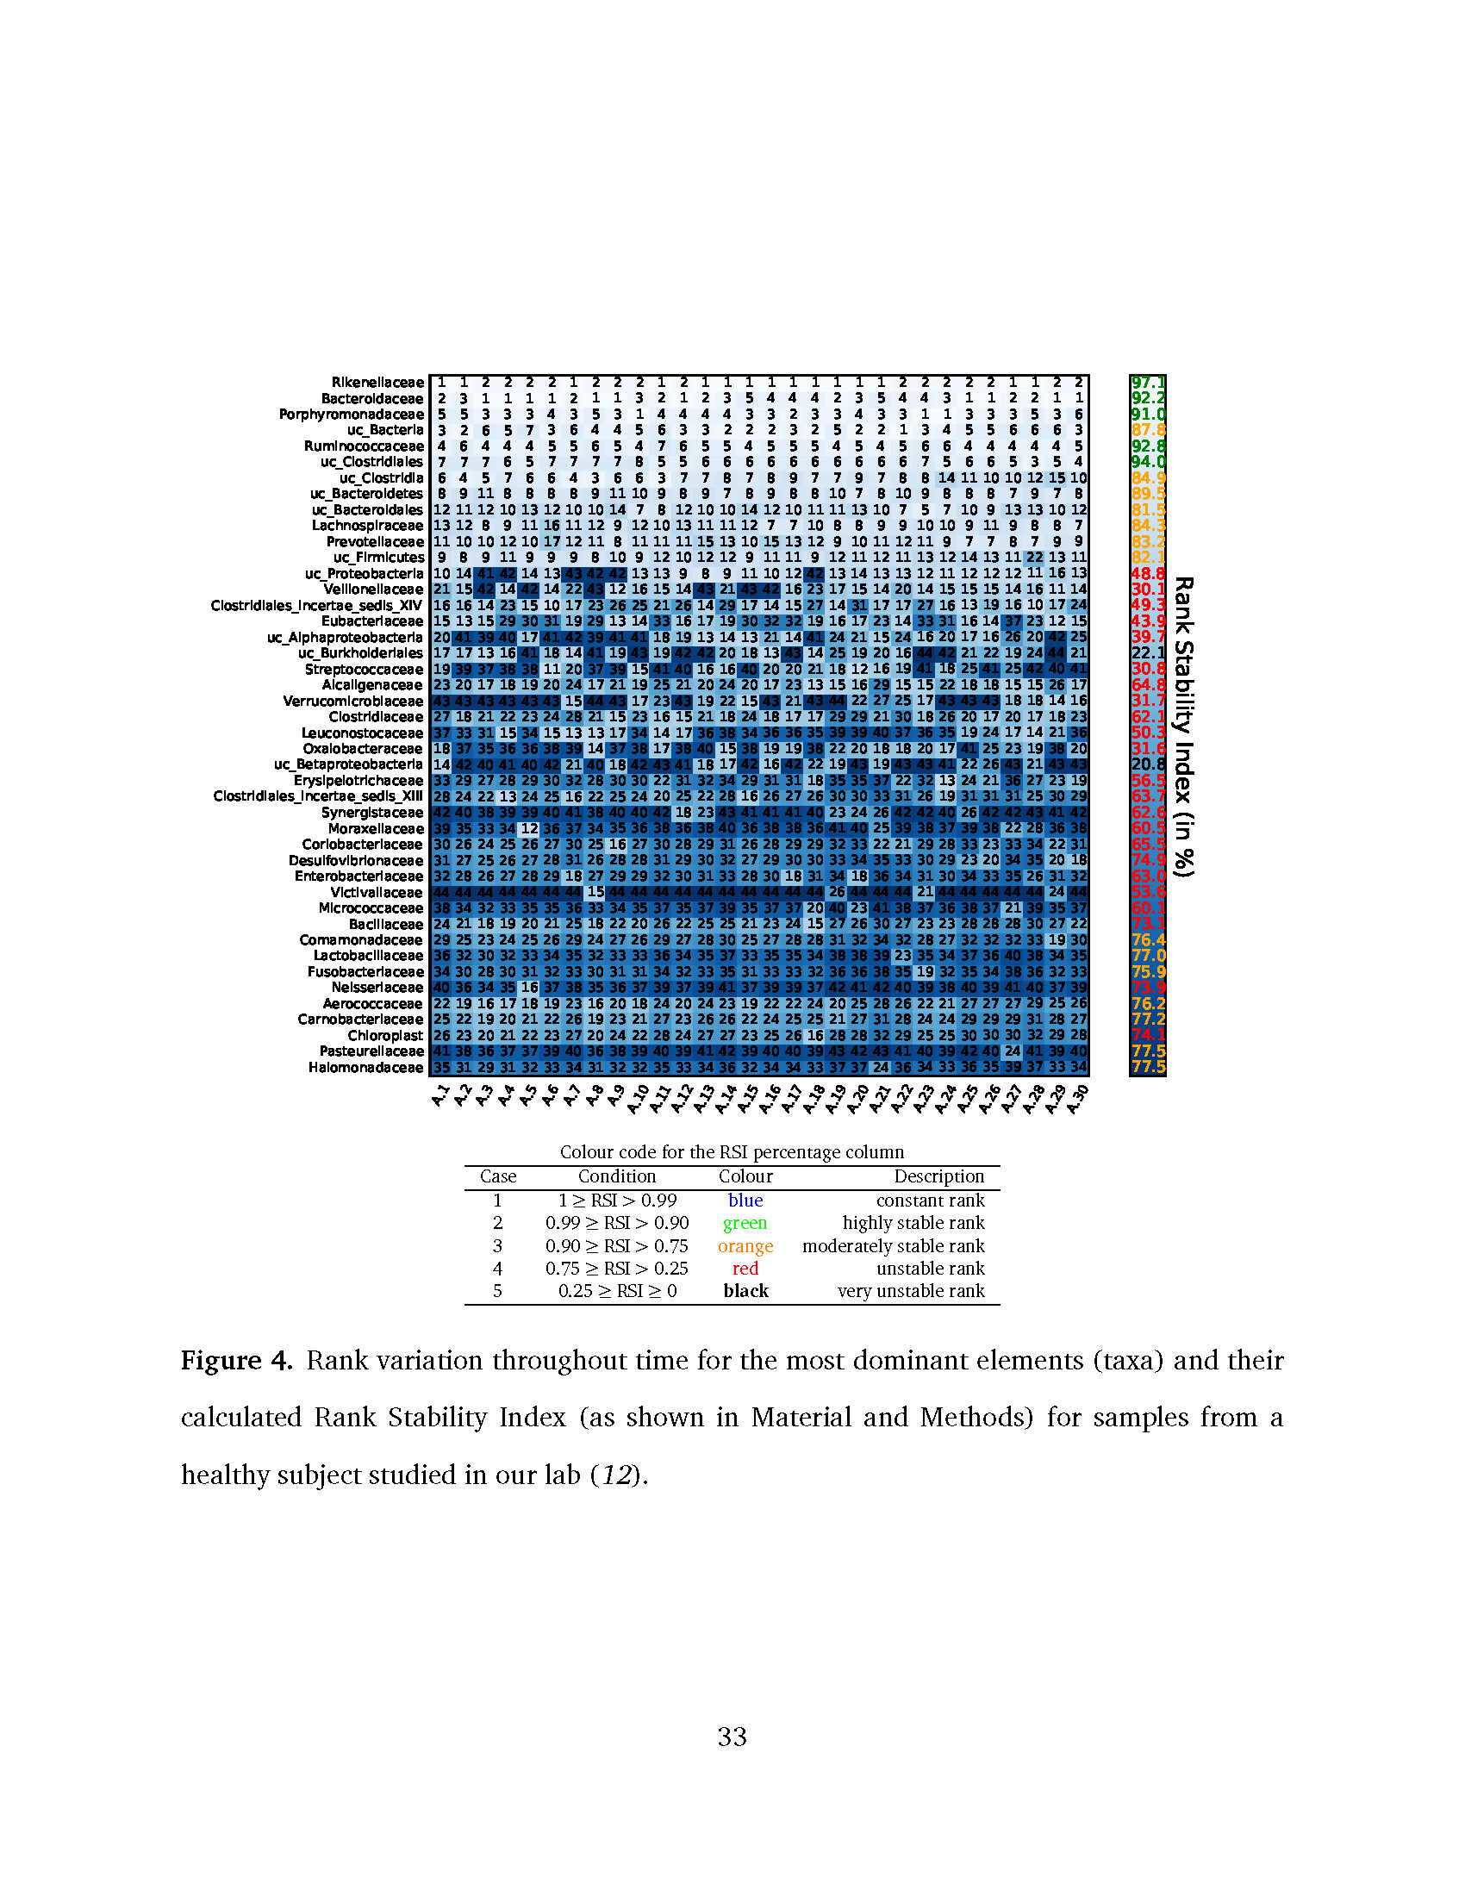

uc_Clostridia 6 4



|  |  |  |  |  |  |  |  |  |  |  |  |  |  |  |  |  |  |  |  |  |  |  |  |  |  |  |  |  |  |  |  |
| --- | --- | --- | --- | --- | --- | --- | --- | --- | --- | --- | --- | --- | --- | --- | --- | --- | --- | --- | --- | --- | --- | --- | --- | --- | --- | --- | --- | --- | --- | --- | --- |
| Rikenellaceae | 1 | 1 | 2 | 2 | 2 | 2 | 1 | 2 | 2 | 2 | 1 | 2 | 1 | 1 | 1 | 1 | 1 | 1 | 1 | 1 | 1 | 2 | 2 | 2 | 2 | 2 | 1 | 1 | 2 | 2 | 97.1 |
| Bacteroidaceae | 2 | 3 | 1 | 1 | 1 | 1 | 2 | 1 | 1 | 3 | 2 | 1 | 2 | 3 | 5 | 4 | 4 | 4 | 2 | 3 | 5 | 4 | 4 | 3 | 1 | 1 | 2 | 2 | 1 | 1 | 92.2 |
| Porphyromonadaceae | 5 | 5 | 3 | 3 | 3 | 4 | 3 | 5 | 3 | 1 | 4 | 4 | 4 | 4 | 3 | 3 | 2 | 3 | 3 | 4 | 3 | 3 | 1 | 1 | 3 | 3 | 3 | 5 | 3 | 6 | 91.0 |
| uc_Bacteria | 3 | 2 | 6 | 5 | 7 | 3 | 6 | 4 | 4 | 5 | 6 | 3 | 3 | 2 | 2 | 2 | 3 | 2 | 5 | 2 | 2 | 1 | 3 | 4 | 5 | 5 | 6 | 6 | 6 | 3 | 87.8 |
| Ruminococcaceae | 4 | 6 | 4 | 4 | 4 | 5 | 5 | 6 | 5 | 4 | 7 | 6 | 5 | 5 | 4 | 5 | 5 | 5 | 4 | 5 | 4 | 5 | 6 | 6 | 4 | 4 | 4 | 4 | 4 | 5 | 92.8 |
| uc_Clostridiales | 7 | 7 | 7 | 6 | 5 | 7 | 7 | 7 | 7 | 8 | 5 | 5 | 6 | 6 | 6 | 6 | 6 | 6 | 6 | 6 | 6 | 6 | 7 | 5 | 6 | 6 | 5 | 3 | 5 | 4 | 94.0 |

5 7 6 6 4

3 6 6

3 7 7 8

7 8 9

7 7 9

7 8 8 14 11 10 10 12 15 10

84.9

uc_Bacteroidetes

8 9 11 8 8

8 8 9 11 10 9 8 9

7 8 9

8 8 10 7

8 10 9

8 8 8 7 9 7 8

89.5

uc_Bacteroidales 12 11 12 10 13 12 10 10 14 7

8 12 10 10 14 12 10 11 11 13 10 7 5

7 10 9 13 13 10 12

81.5

Lachnospiraceae 13 12 8

9 11 16 11 12 9 12 10 13 11 11 12 7

7 10 8 8 9

9 10 10 9 11 9 8 8 7

84.3

Prevotellaceae 11 10 10 12 10 17 12 11 8 11 11 11 15 13 10 15 13 12 9 10 11 12 11 9

7 7 8

7 9 9

83.2

uc_Firmicutes 9

8 9 11 9 9 9

8 10 9 12 10 12 12 9 11 11 9 12 11 12 11 13 12 14 13 11 22 13 11

82.1

uc_Proteobacteria 10 14 41 42 14 13 43 42 42 13 13 9

Rank Stability Index (in %)

8 9 11 10 12 42 13 14 13 13 12 11 12 12 12 11 16 13

48.8

Veillonellaceae 21 15 42 14 42 14 22 43 12 16 15 14 43 21 43 42 16 23 17 15 14 20 14 15 15 15 14 16 11 14

30.1

Clostridiales_incertae_sedis_XIV

16 16 14 23 15 10 17 23 26 25 21 26 14 29 17 14 15 27 14 31 17 17 27 16 13 19 16 10 17 24

49.3

Eubacteriaceae 15 13 15 29 30 31 19 29 13 14 33 16 17 19 30 32 32 19 16 17 23 14 33 31 16 14 37 23 12 15

uc_Alphaproteobacteria 20 41 39 40 17 41 42 39 41 41 18 19 13 14 13 21 14 41 24 21 15 24 16 20 17 16 26 20 42 25

uc_Burkholderiales 17 17 13 16 41 18 14 41 19 43 19 42 42 20 18 13 43 14 25 19 20 16 44 42 21 22 19 24 44 21

Streptococcaceae 19 39 37 38 38 11 20 37 39 15 41 40 16 16 40 20 20 21 18 12 16 19 41 18 25 41 25 42 40 41

Alcaligenaceae 23 20 17 18 19 20 24 17 21 19 25 21 20 24 20 17 23 13 15 16 29 15 15 22 18 18 15 15 26 17

Verrucomicrobiaceae 43 43 43 43 43 43 15 44 43 17 23 43 19 22 15 43 21 43 44 22 27 25 17 43 43 43 18 18 14 16

Clostridiaceae 27 18 21 22 23 24 28 21 15 23 16 15 21 18 24 18 17 17 29 29 21 30 18 26 20 17 20 17 18 23

Leuconostocaceae 37 33 31 15 34 15 13 13 17 34 14 17 36 38 34 36 36 35 39 39 40 37 36 35 19 24 17 14 21 36

Oxalobacteraceae 18 37 35 36 36 38 39 14 37 38 17 38 40 15 38 19 19 38 22 20 18 18 20 17 41 25 23 19 38 20

uc_Betaproteobacteria 14 42 40 41 40 42 21 40 18 42 43 41 18 17 42 16 42 22 19 43 19 43 43 41 22 26 43 21 43 43

Erysipelotrichaceae 33 29 27 28 29 30 32 28 30 30 22 31 32 34 29 31 31 18 35 35 37 22 32 13 24 21 36 27 23 19

Clostridiales_incertae_sedis_XIII 28 24 22 13 24 25 16 22 25 24 20 25 22 28 16 26 27 26 30 30 33 31 26 19 31 31 31 25 30 29

Synergistaceae 42 40 38 39 39 40 41 38 40 40 42 18 23 43 41 41 41 40 23 24 26 42 42 40 26 42 42 43 41 42

Moraxellaceae 39 35 33 34 12 36 37 34 35 36 38 36 38 40 36 38 38 36 41 40 25 39 38 37 39 38 22 28 36 38

Coriobacteriaceae 30 26 24 25 26 27 30 25 16 27 30 28 29 31 26 28 29 29 32 33 22 21 29 28 33 23 33 34 22 31

Desulfovibrionaceae 31 27 25 26 27 28 31 26 28 28 31 29 30 32 27 29 30 30 33 34 35 33 30 29 23 20 34 35 20 18

Enterobacteriaceae 32 28 26 27 28 29 18 27 29 29 32 30 31 33 28 30 18 31 34 18 36 34 31 30 34 33 35 26 31 32

Victivallaceae 44 44 44 44 44 44 44 15 44 44 44 44 44 44 44 44 44 44 26 44 44 44 21 44 44 44 44 44 24 44

Micrococcaceae 38 34 32 33 35 35 36 33 34 35 37 35 37 39 35 37 37 20 40 23 41 38 37 36 38 37 21 39 35 37

Bacillaceae 24 21 18 19 20 21 25 18 22 20 26 22 25 25 21 23 24 15 27 26 30 27 23 23 28 28 28 30 27 22

Comamonadaceae 29 25 23 24 25 26 29 24 27 26 29 27 28 30 25 27 28 28 31 32 34 32 28 27 32 32 32 33 19 30

Lactobacillaceae 36 32 30 32 33 34 35 32 33 33 36 34 35 37 33 35 35 34 38 38 39 23 35 34 37 36 40 38 34 35

Fusobacteriaceae 34 30 28 30 31 32 33 30 31 31 34 32 33 35 31 33 33 32 36 36 38 35 19 32 35 34 38 36 32 33

Neisseriaceae 40 36 34 35 16 37 38 35 36 37 39 37 39 41 37 39 39 37 42 41 42 40 39 38 40 39 41 40 37 39

Aerococcaceae 22 19 16 17 18 19 23 16 20 18 24 20 24 23 19 22 22 24 20 25 28 26 22 21 27 27 27 29 25 26

Carnobacteriaceae 25 22 19 20 21 22 26 19 23 21 27 23 26 26 22 24 25 25 21 27 31 28 24 24 29 29 29 31 28 27

Chloroplast 26 23 20 21 22 23 27 20 24 22 28 24 27 27 23 25 26 16 28 28 32 29 25 25 30 30 30 32 29 28

Pasteurellaceae 41 38 36 37 37 39 40 36 38 39 40 39 41 42 39 40 40 39 43 42 43 41 40 39 42 40 24 41 39 40

Halomonadaceae 35 31 29 31 32 33 34 31 32 32 35 33 34 36 32 34 34 33 37 37 24 36 34 33 36 35 39 37 33 34

43.9

39.7

22.1

30.8

64.8

31.7

62.1

50.3

31.6

20.8

56.5

63.7

62.6

60.5

65.5

74.9

63.0

53.6

60.1

73.1

76.4

77.0

75.9

73.9

76.2

77.2

74.1

77.5

77.5

Colour code for the RSI percentage column

|  |  |  |  |
| --- | --- | --- | --- |
| Case | Condition | Colour | Description |
| 1 | 1 *≥* RSI *>* 0.99 | blue | constant rank |
| 2 | 0.99 *≥* RSI *>* 0.90 | green | highly stable rank |
| 3 | 0.90 *≥* RSI *>* 0.75 | orange | moderately stable rank |
| 4 | 0.75 *≥* RSI *>* 0.25 | red | unstable rank |

5 0.25 *≥* RSI *≥* 0 **black** very unstable rank

**Figure 4.** Rank variation throughout time for the most dominant elements (taxa) and their calculated Rank Stability Index (as shown in Material and Methods) for samples from a healthy subject studied in our lab (*12*).

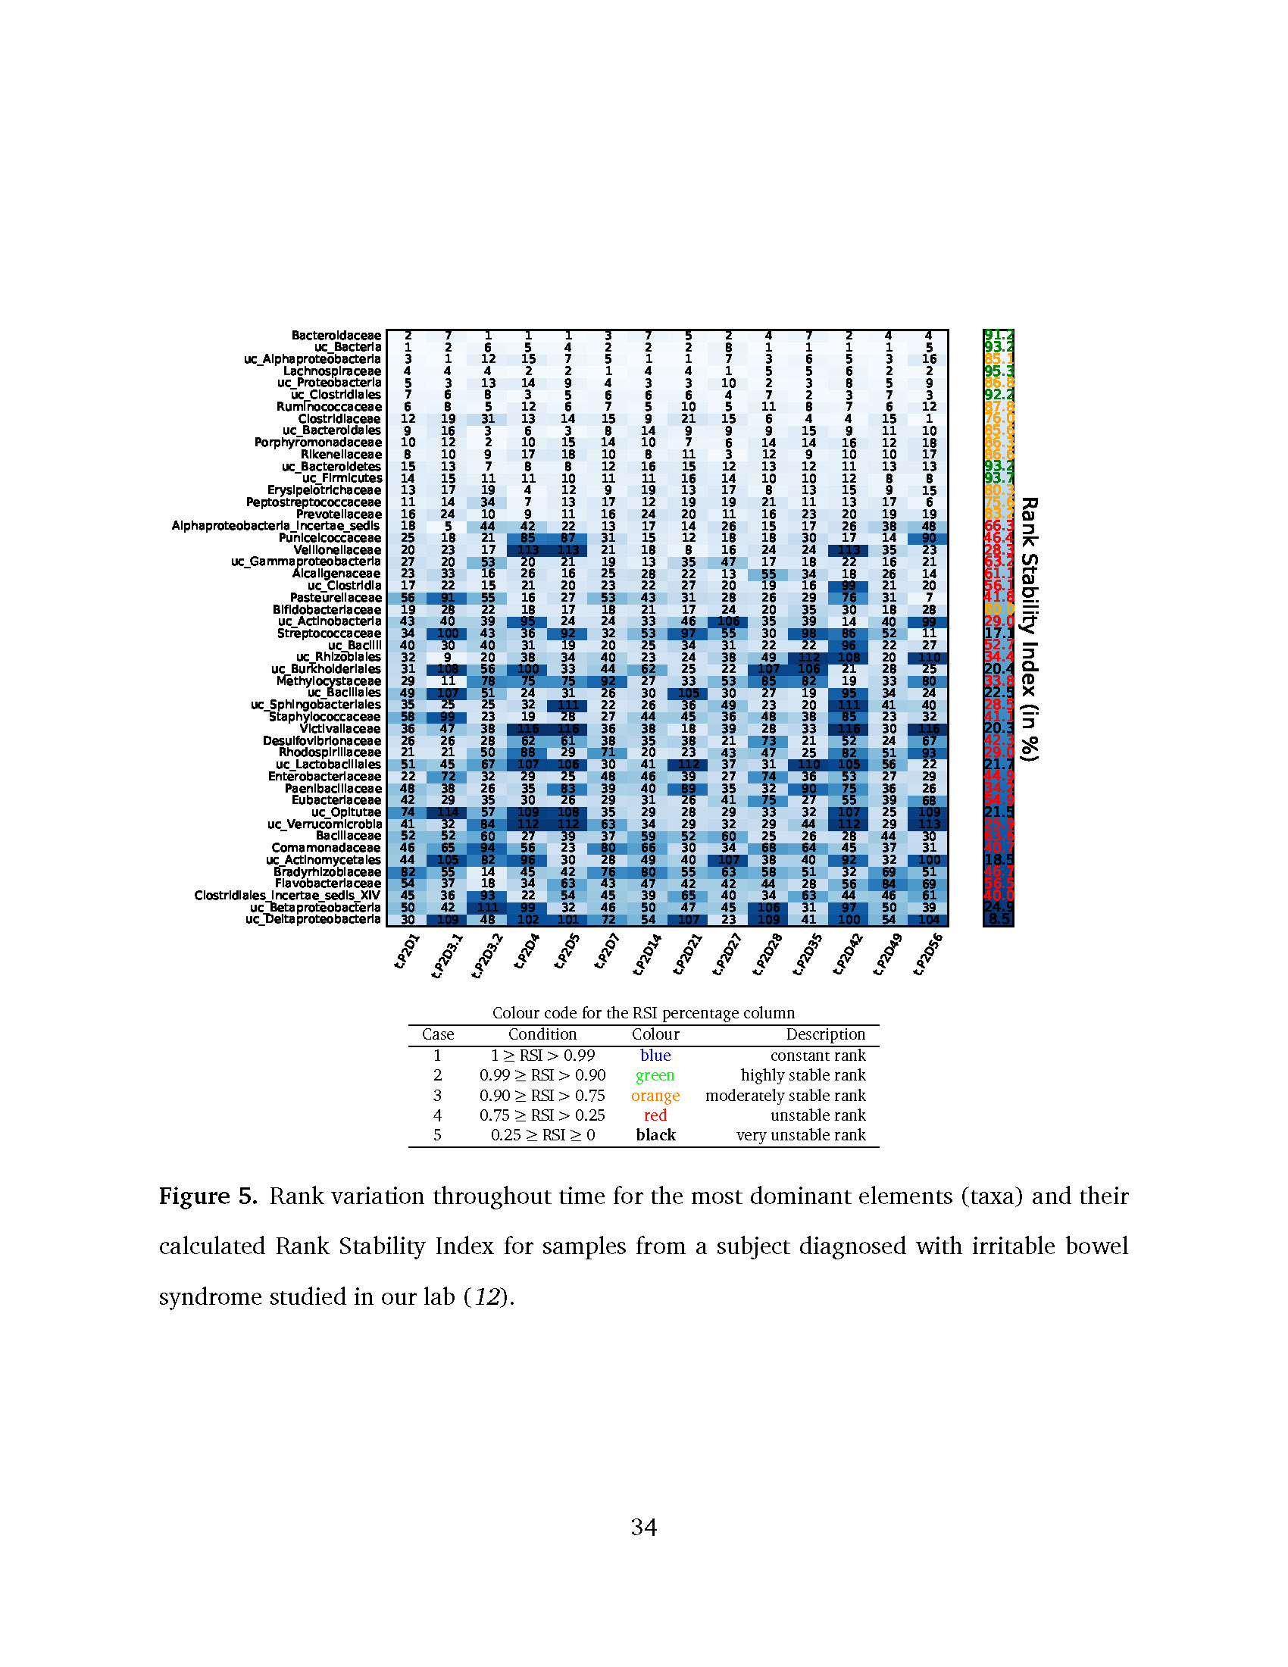

Bacteroidaceae uc_Bacteria uc_Alphaproteobacteria Lachnospiraceae uc_Proteobacteria uc_Clostridiales Ruminococcaceae Clostridiaceae uc_Bacteroidales Porphyromonadaceae



2 7 1 1 1 3 7 5 2 4 7 2 4 4

1 2 6 5 4 2 2 2 8 1 1 1 1 5

3 1 12 15 7 5 1 1 7 3 6 5 3 16

4 4 4 2 2 1 4 4 1 5 5 6 2 2

5 3 13 14 9 4 3 3 10 2 3 8 5 9

7 6 8 3 5 6 6 6 4 7 2 3 7 3

6 8 5 12 6 7 5 10 5 11 8 7 6 12

12 19 31 13 14 15 9 21 15 6 4 4 15 1

9 16 3 6 3 8 14 9 9 9 15 9 11 10

10 12 2 10 15 14 10 7 6 14 14 16 12 18

8 10 9 17 18 10 8 11 3 12 9 10 10 17

15 13 7 8 8 12 16 15 12 13 12 11 13 13

14 15 11 11 10 11 11 16 14 10 10 12 8 8

13 17 19 4 12 9 19 13 17 8 13 15 9 15

11 14 34 7 13 17 12 19 19 21 11 13 17 6

16 24 10 9 11 16 24 20 11 16 23 20 19 19

18 5 44 42 22 13 17 14 26 15 17 26 38 48

25 18 21 85 87 31 15 12 18 18 30 17 14 90

20 23 17 113 113 21 18 8 16 24 24 113 35 23

27 20 53 20 21 19 13 35 47 17 18 22 16 21

23 33 16 26 16 25 28 22 13 55 34 18 26 14

17 22 15 21 20 23 22 27 20 19 16 99 21 20

56 91 55 16 27 53 43 31 28 26 29 76 31 7

19 28 22 18 17 18 21 17 24 20 35 30 18 28

43 40 39 95 24 24 33 46 106 35 39 14 40 99

34 100 43 36 92 32 53 97 55 30 98 86 52 11

40 30 40 31 19 20 25 34 31 22 22 96 22 27

32 9 20 38 34 40 23 24 38 49 112 108 20 110

31 108 56 100 33 44 62 25 22 107 106 21 28 25

29 11 78 75 75 92 27 33 53 85 82 19 33 80

49 107 51 24 31 26 30 105 30 27 19 95 34 24

35 25 25 32 111 22 26 36 49 23 20 111 41 40

58 99 23 19 28 27 44 45 36 48 38 85 23 32

36 47 38 116 116 36 38 18 39 28 33 116 30 116

26 26 28 62 61 38 35 38 21 73 21 52 24 67

21 21 50 88 29 71 20 23 43 47 25 82 51 93

51 45 67 107 106 30 41 112 37 31 110 105 56 22

22 72 32 29 25 48 46 39 27 74 36 53 27 29

48 38 26 35 83 39 40 89 35 32 90 75 36 26

42 29 35 30 26 29 31 26 41 75 27 55 39 68

74 114 57 109 108 35 29 28 29 33 32 107 25 109

41 32 84 112 112 63 34 29 32 29 44 112 29 113

52 52 60 27 39 37 59 52 60 25 26 28 44 30

46 65 94 56 23 80 66 30 34 68 64 45 37 31

44 105 82 96 30 28 49 40 107 38 40 92 32 100

82 55 14 45 42 76 80 55 63 58 51 32 69 51

54 37 18 34 63 43 47 42 42 44 28 56 84 69

45 36 93 22 54 45 39 65 40 34 63 44 46 61

50 42 111 99 32 46 50 47 45 106 31 97 50 39

30 109 48 102 101 72 54 107 23 109 41 100 54 104

Rikenellaceae uc_Bacteroidetes uc_Firmicutes Erysipelotrichaceae Peptostreptococcaceae

Prevotellaceae Alphaproteobacteria_incertae_sedis

Puniceicoccaceae Veillonellaceae uc_Gammaproteobacteria

Alcaligenaceae uc_Clostridia Pasteurellaceae Bifidobacteriaceae uc_Actinobacteria Streptococcaceae

uc_Bacilli uc_Rhizobiales uc_Burkholderiales Methylocystaceae uc_Bacillales uc_Sphingobacteriales Staphylococcaceae Victivallaceae Desulfovibrionaceae Rhodospirillaceae uc_Lactobacillales Enterobacteriaceae Paenibacillaceae Eubacteriaceae uc_Opitutae uc_Verrucomicrobia

Bacillaceae Comamonadaceae uc_Actinomycetales Bradyrhizobiaceae Flavobacteriaceae Clostridiales_incertae_sedis_XIV uc_Betaproteobacteria uc_Deltaproteobacteria

91.2

93.2

85.1

95.3

86.8

92.2

87.8

76.0

85.6

86.3

86.6

93.2

93.7

80.3

Rank Stability Index (in %)

75.6

83.2

66.3

46.4

28.3

63.2

61.1

56.1

41.8

80.0

29.0

17.1

52.7

34.4

20.4

33.8

22.5

28.5

41.1

20.3

42.3

29.0

21.7

44.9

34.2

54.9

21.5

25.9

63.6

40.7

18.5

46.7

56.5

40.0

24.9

8.5

Colour code for the RSI percentage column

|  |  |  |  |
| --- | --- | --- | --- |
| Case | Condition | Colour | Description |
| 1 | 1 *≥* RSI *>* 0.99 | blue | constant rank |
| 2 | 0.99 *≥* RSI *>* 0.90 | green | highly stable rank |
| 3 | 0.90 *≥* RSI *>* 0.75 | orange | moderately stable rank |
| 4 | 0.75 *≥* RSI *>* 0.25 | red | unstable rank |

5 0.25 *≥* RSI *≥* 0 **black** very unstable rank

**Figure 5.** Rank variation throughout time for the most dominant elements (taxa) and their calculated Rank Stability Index for samples from a subject diagnosed with irritable bowel syndrome studied in our lab (*12*).

0 100 200 300

●

●

●

●

●

●     ●

● ●●

●

●

●

●

●

●

●

●

●

●●

●

●  ●

●

●

●

●

●

●

●

●●

●   ●

●

●

● ●

●

●

●  ●

●

●

●

●

●

●

●

●●

●

●●

● ●

●        ●

● ●

●

●●

●

●

●

●●

0.5

0.4

●

●

●●

●

●

●   ●●

●

●

●

●

●

●

●

●

●

0.3

●●

●

●

●

●●    ●

● ●

●

●

●

●

●

●

●

●●

●

●

●

●●

●

●

●

●

●

●● ●

●

●

●

●

●

●

●●

●●

●

●●

●●

●

●

●●

●

●

●

●

●

●

●

●

●●

●

●

●●    ●

● ●●

●●

●

●

●

●

0.2

●

●

●  ●

●●●

●●

●

●

●     ●●  ●

●●●   ●●

●

●

●

●●

●●●

●●

●

●

● ●  ●

●●●●

●

●●

●

●

●

●

●●●

●●

●

●

●

●●●   ●

●

●

●

●

●

●

●●●●●

● ●

0.1

●●

●●

●●●●● ●●  ●●

●

●●  ●

●●●●● ●●●

●●●

●●●●●

●

●

●●

●

●

●

●●

●●

●

●

●●

●

●

●

● ●●

●

●

●

●       ●●●●●

●●

●●

●

●

●●●●

●

●●●

●

●●●

●●

●

●

●

●●

●●●

●

0.0

V

0 50 100

t (days)

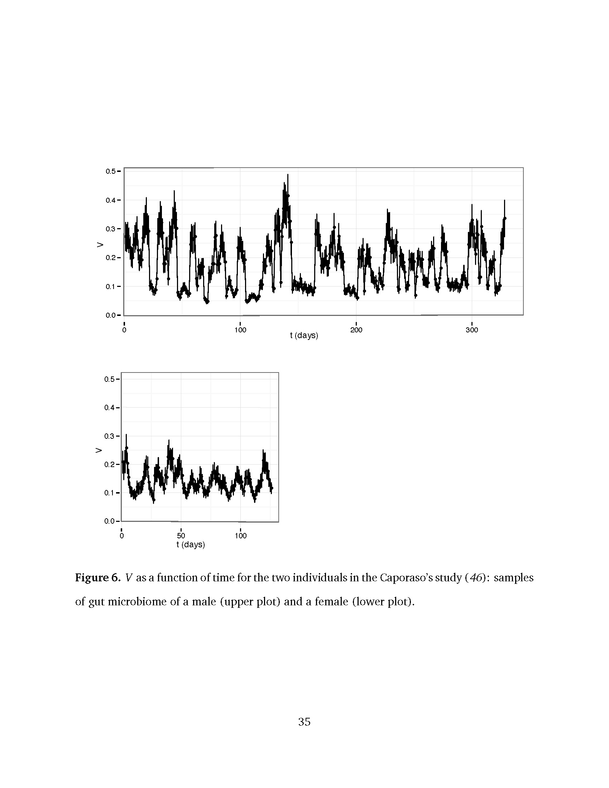

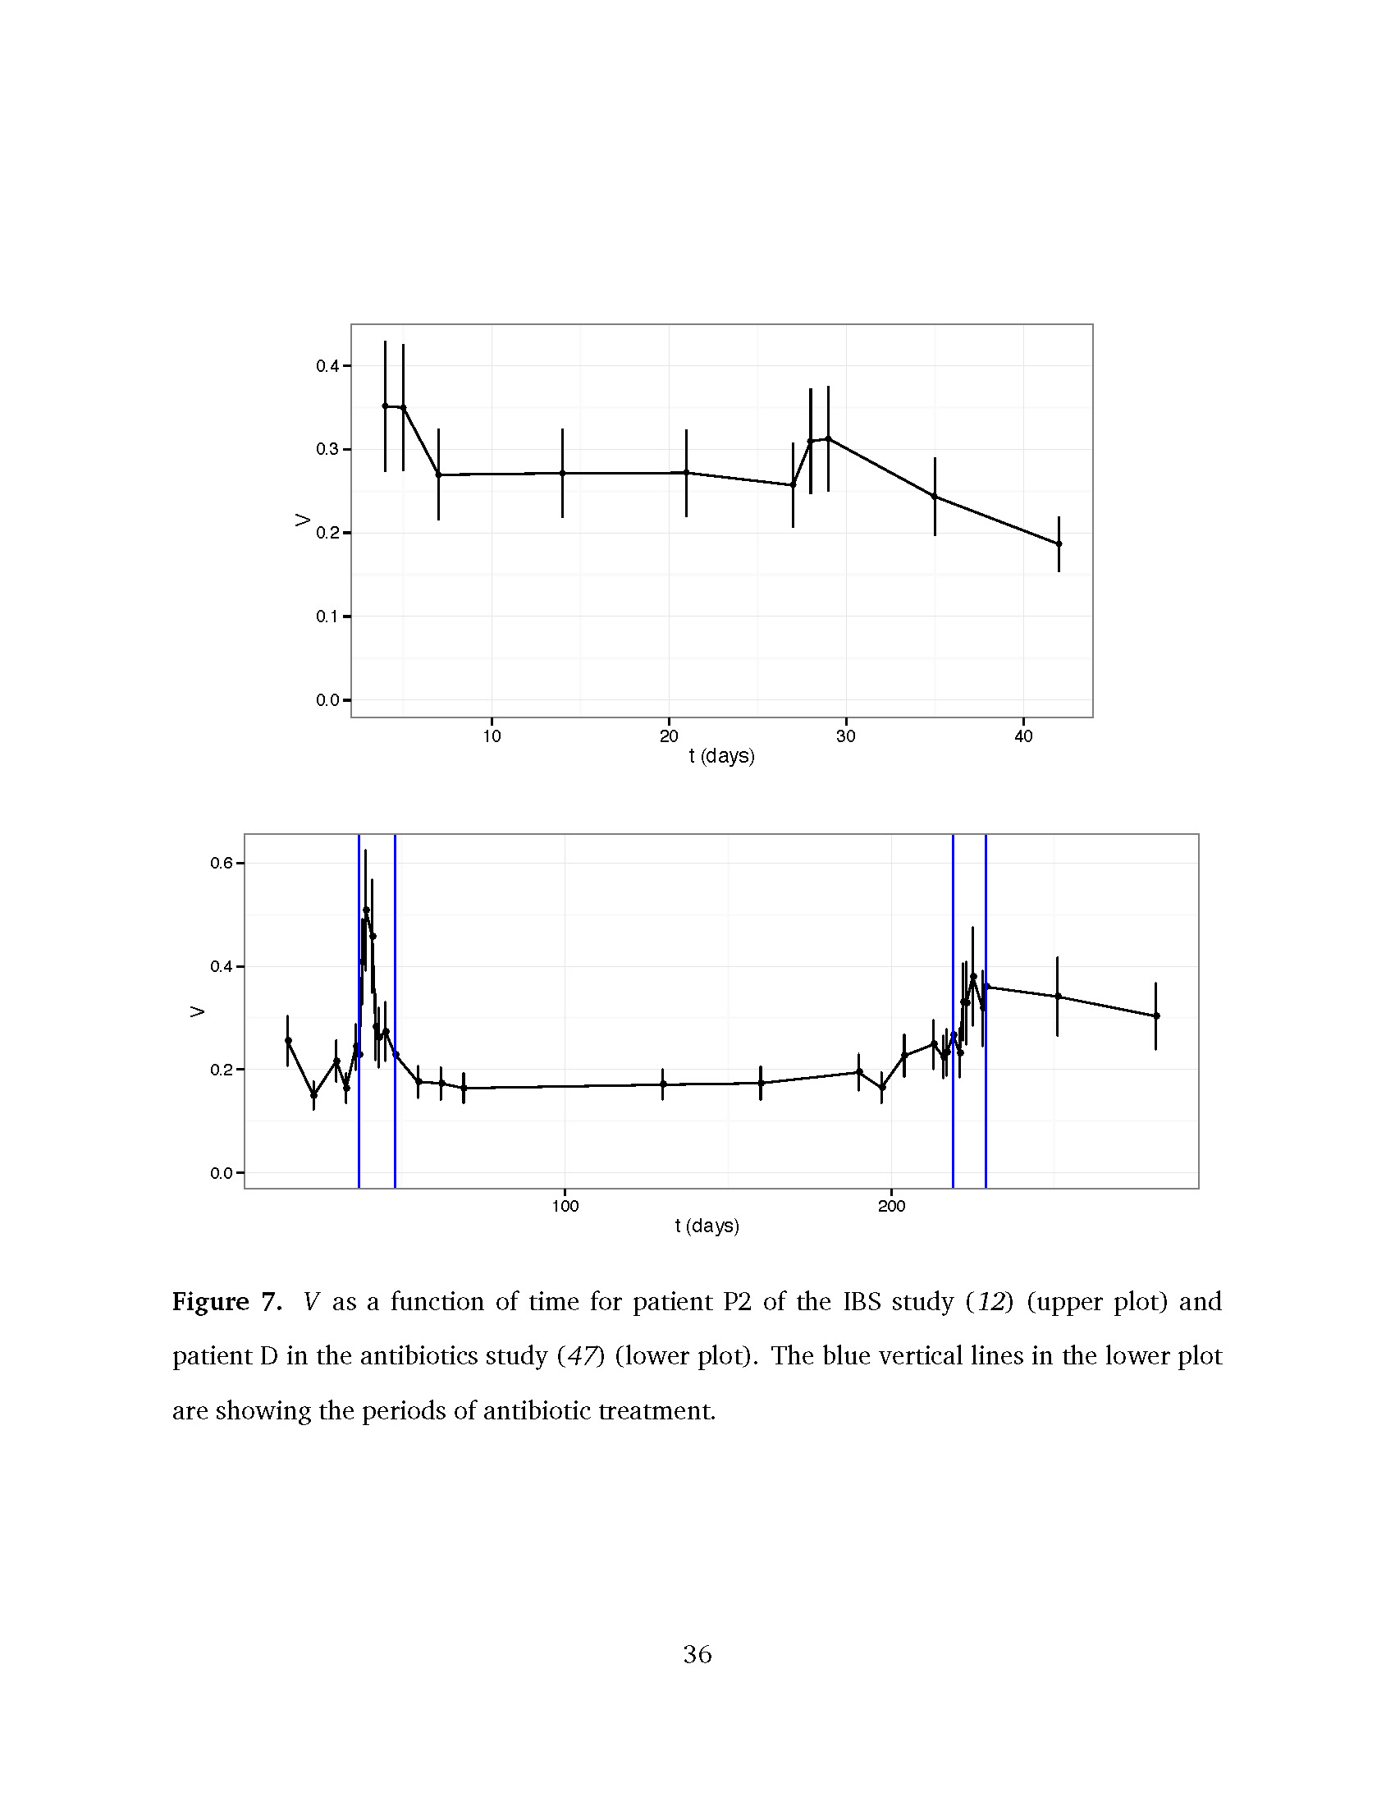

0.4

●

●

●

●

●

●

●

●

● ●

0.3

0.2

V

0.1

0.0

10 20 30 40

t (days)

100 200

●

●

●

●

●

●

●

●

●

●

●

●

0.6

●

0.4

●

●●

●

●

●

●

●

● ●

●

0.2

●

●

●

●

●

●

●

●

●

0.0

V

t (days)

**Figure 7.** *V* as a function of time for patient P2 of the IBS study (*12*) (upper plot) and patient D in the antibiotics study (*47*) (lower plot). The blue vertical lines in the lower plot are showing the periods of antibiotic treatment.



